|  |
| --- |
| Kingdom of Saudi Arabia  Ministry of Education  Imam Abdulrahman bin Faisal University  Computer Science department  College of Science and Humanities |



**CIS422-Human Computer Interaction**

For

My Uni Guide



CIS Year 4, G1

Dr. Norah Aldenaini

*9 February 2023*

**Content:**

**Team Members:** 3

**List of figures:** 4

**List of tables:** 6

**User analysis:** 20

**Task analysis:** 21

**Paper prototype (Balasmiq) [3]:** 23

**Initial software prototype (Axure) [6]:** 52

**Concluding discussion:** 62

**References:** 62

# **Team Members:**

|  |  |  |  |
| --- | --- | --- | --- |
| **Leader** | **ID** | **Member Name** | **Email Address** |
| € | 2200004242 | Bushra Alshehri | 2200004242@iau.edu.sa |
| € | 2200003453 | Fatima Alrastem | 2200003453@iau.edu.sa |
| € | 2200006257 | Albandari Alsanhani | 2200006257@iau.edu.sa |
| € | 2200005678 | Dana Kurdi | 2200005678@iau.edu.sa |
| € | 2200006269 | Jumana Aljassim | 2200006269@iau.edu.sa |

### Team members table

# **List of figures:**

Figure 1 7

Figure 2 8

Figure 3 8

Figure 4 8

Figure 6 8

Figure 5 8

Figure 7 9

Figure 8 9

Figure 9 9

Figure 10 10

Figure 11 11

Figure 12 12

Figure 13 13

Figure 14 13

Figure 15 14

Figure 16 14

Figure 17 14

Figure 18 15

Figure 19 15

Figure 20 16

Figure 21 16

Figure 22 17

Figure 23 17

Figure 24 18

Figure 25 18

Figure 26: Home page 23

Figure 27: Login page 24

Figure 28: Forget password page 25

Figure 29: Signup page 26

Figure 30: Timeline page 27

Figure 31: User account page 28

Figure 32: My orders page 29

Figure 33: Activities page 30

Figure 34: Edit profile page 31

Figure 35: Customization page 32

Figure 36:Likes page 33

Figure 37: Repost page 34

Figure 38: Messages page 35

Figure 39: Admin account page 36

Figure 40: Orders page 37

Figure 41: Home page 38

Figure 42: Login page 39

Figure 43: Sign up page 40

Figure 44: User account page 41

Figure 45: My orders page 42

Figure 46:Notification page 43

Figure 47: Messages page 44

Figure 48: Edit profile page 45

Figure 49: Settings page 46

Figure 50: Timeline page 47

Figure 51: Events page 48

Figure 52: Side bar page 49

Figure 53: Admin account page 50

Figure 54: Orders page 51

Figure 55:Home page 52

Figure 56: Login page 52

Figure 57: Forget password page 53

Figure 58:Sign up page 53

Figure 59: Timeline page 54

Figure 60: User account page 54

Figure 61: My planner page 55

Figure 62: My planner page 55

Figure 63: Likes and Repost page 56

Figure 64: Likes and Repost page 56

Figure 65: Likes and Repost page 57

Figure 66: DM page 1 57

Figure 67: Add new contact page 58

Figure 68: DM page 2 58

Figure 69: DM page 3 59

Figure 70: DM page 4 59

Figure 71: Phone call page 60

Figure 72: Video call page 60

Figure 73: Customization page 61

Figure 74: Contact us page 61

# **List of tables:**

Team members table 3

**Introduction:**

As students of the fourth year in college, we faced a few issues during our study years such as finding course resources, extra teaching courses, creating study groups, and more. Based on that we want to consider this problem, so we came up with the idea of our application’s My Uni Guide to provide helpful guiding and facilitate the students’ needs for all of the students like, preparatory year students, undergraduate students, and even graduate students by sharing their experiences and good advice for guidance [1]. We will create an application that makes the process of communication between students, publishing updates and experiences, and getting the latest updates easily through a comfortable environment for them.  The application will contain multiple features that make it easier for students to move, inquire and search for information about all faculties of the university, which will save a lot of effort and time for them [2].

**Literature Review of similar system:**

**1- First system:** [**https://www.theuniguide.co.uk/**](https://www.theuniguide.co.uk/)

1. Clear headings shown in the Homepage.

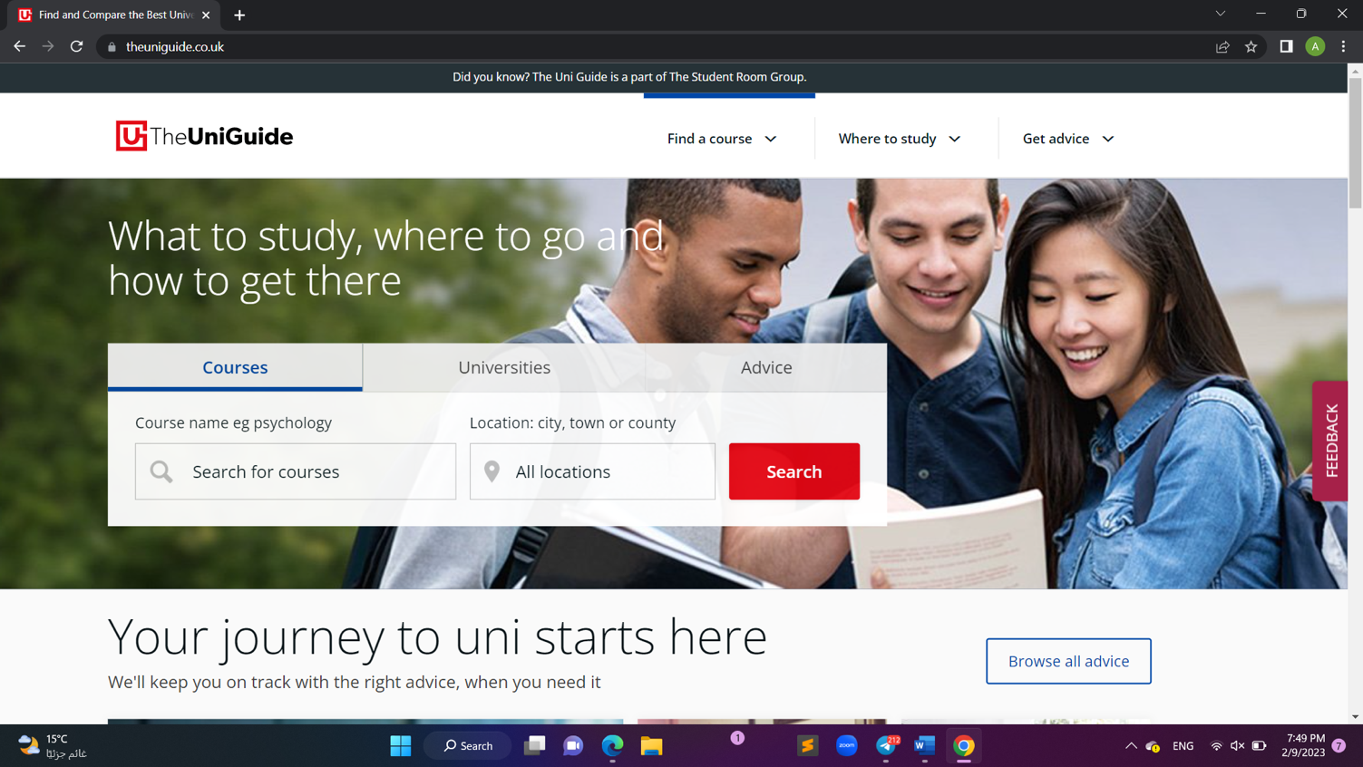

## Figure 1

1. A clear description of each section of the site as shown in the next three figures:

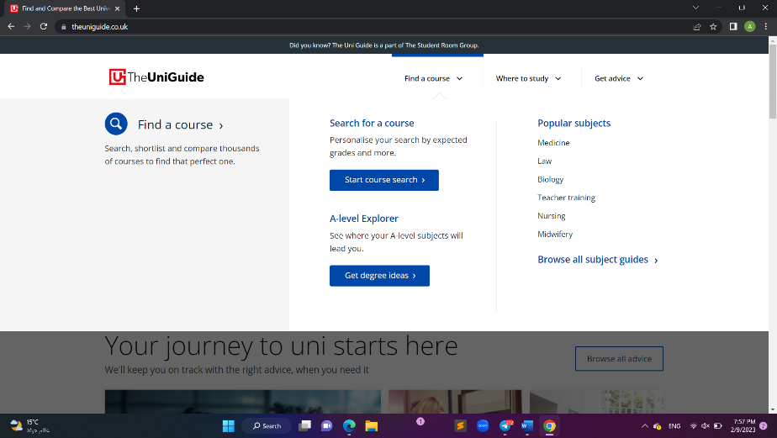

## Figure 2

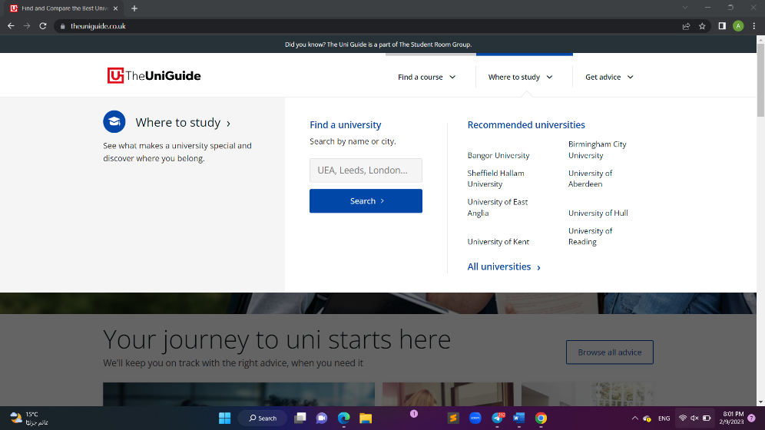

## Figure 3

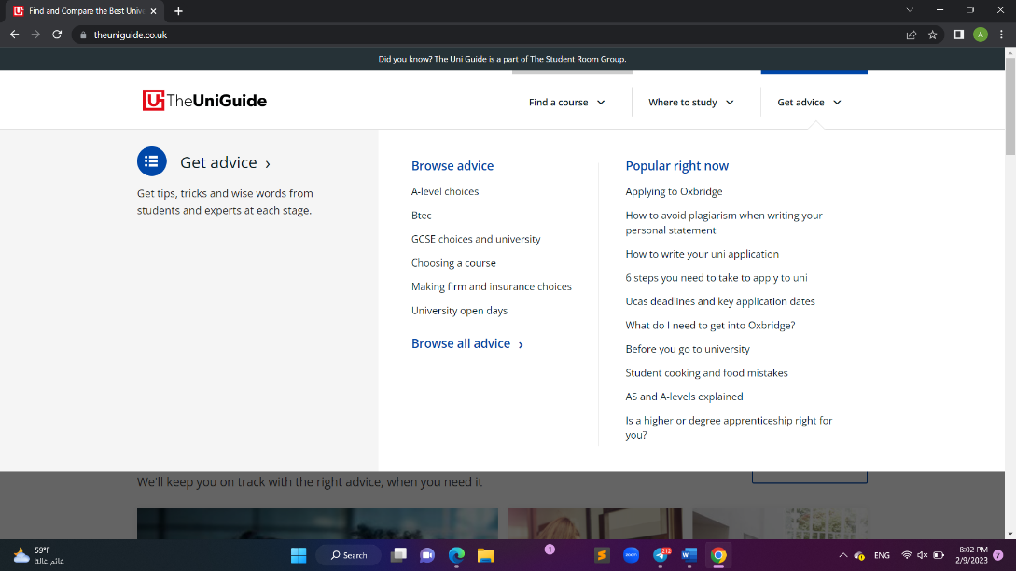

## Figure 4

1. 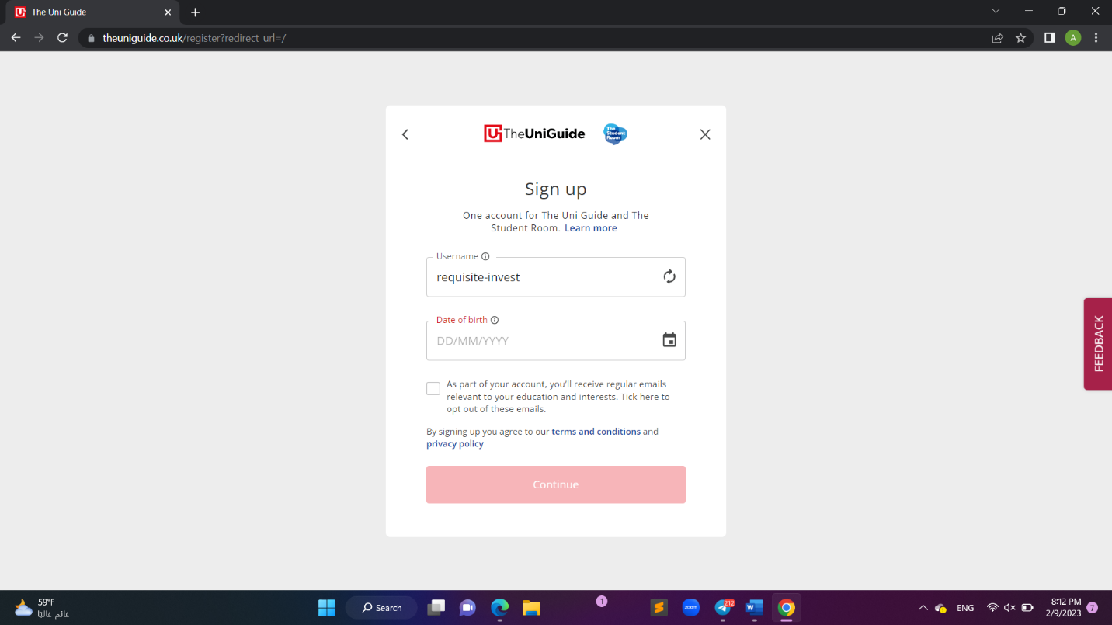User can easily register an account using Googke account and then choose username and password

## Figure 6

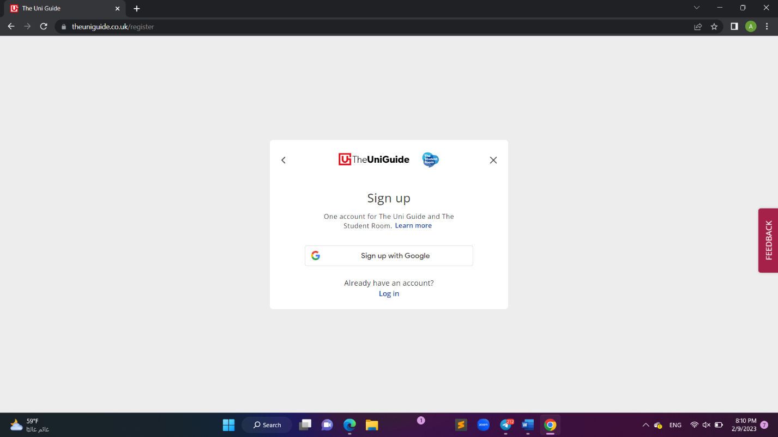

## Figure 5

1. Quick and easy access box to search for what you need

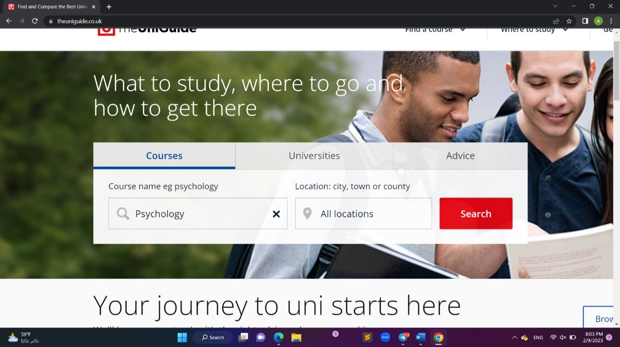

## Figure 7

1. The experience of searching for a course and then requesting information, as shown below in the pictures, was clear and without complications.

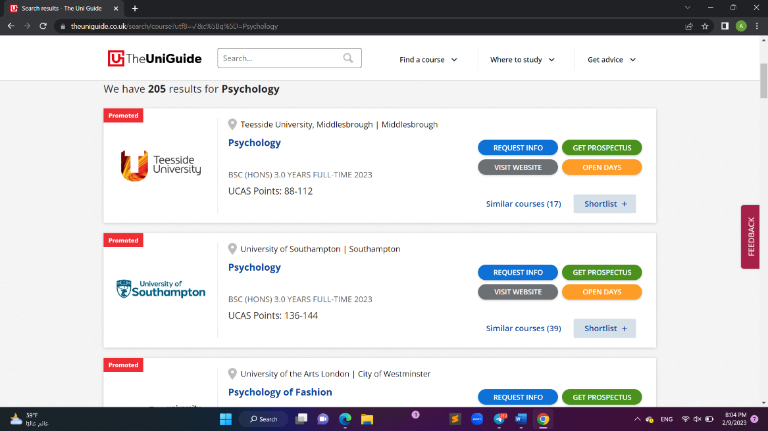

## Figure 8

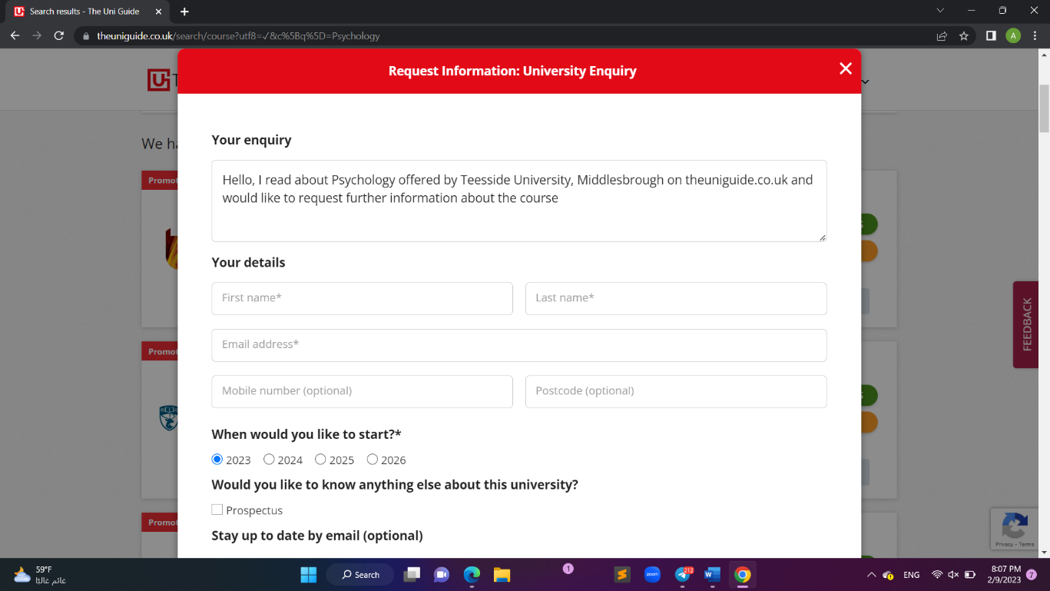

## Figure 9

**2- Second system: Edmodoworld application.**

1. Simple registering and login form interface.

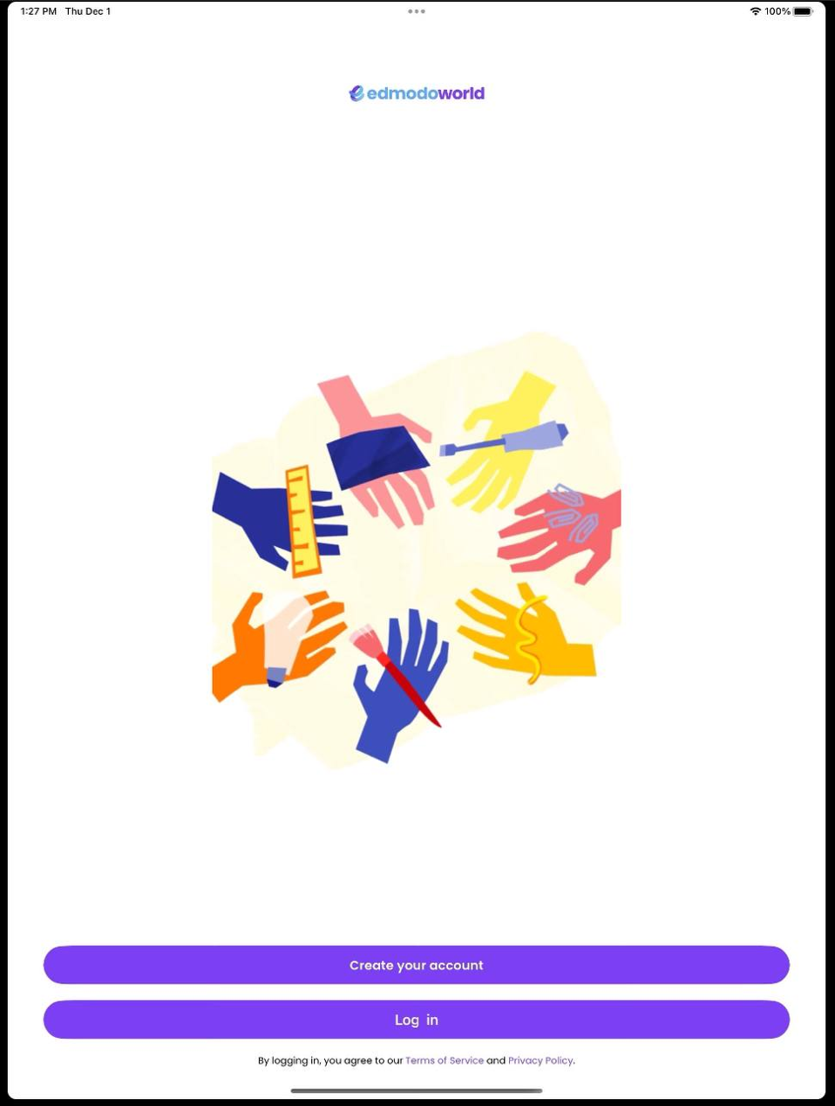

## Figure 10

1. Distinctive modern interfaces that contain a clear navigation bar, the home page includes the most important main sections that the user needs quick access to, such as Classes and Groups.

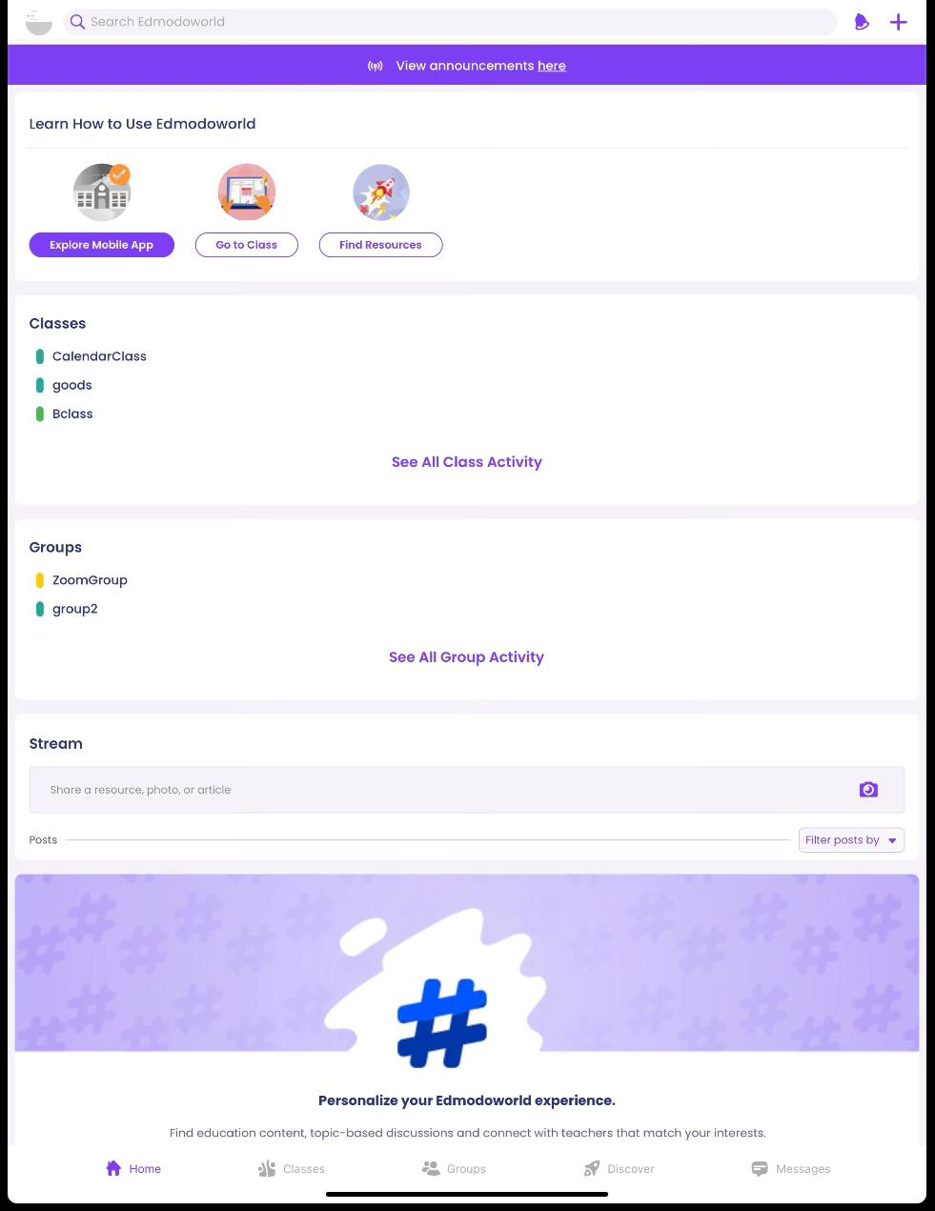

## Figure 11

1. Registered activities and classes displayed clearly, making it easy for the user to know all the information related to his activities.

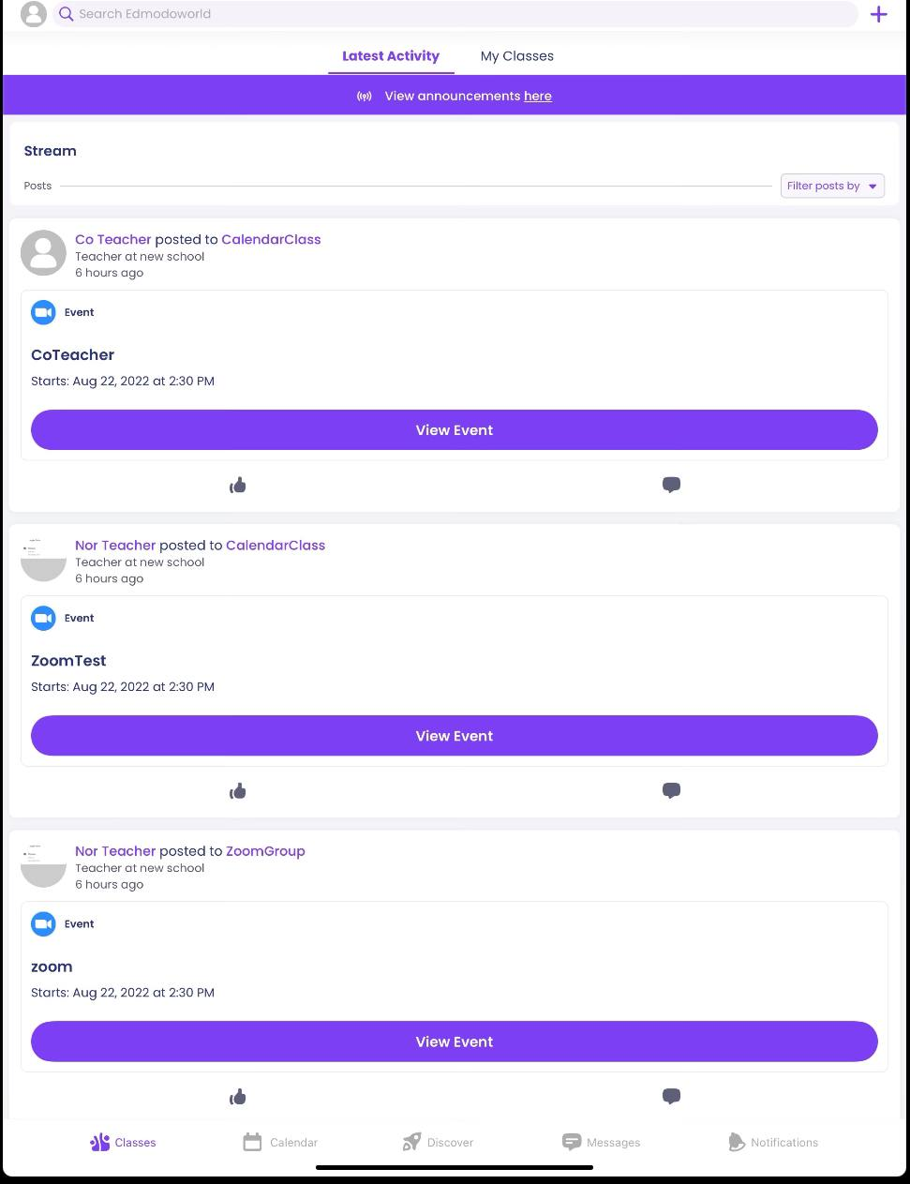

## Figure 12

**3- Third system: <https://theuniguide.com.au/>**

1. Black and white homepage with great design, login included in navigation bar clearly.

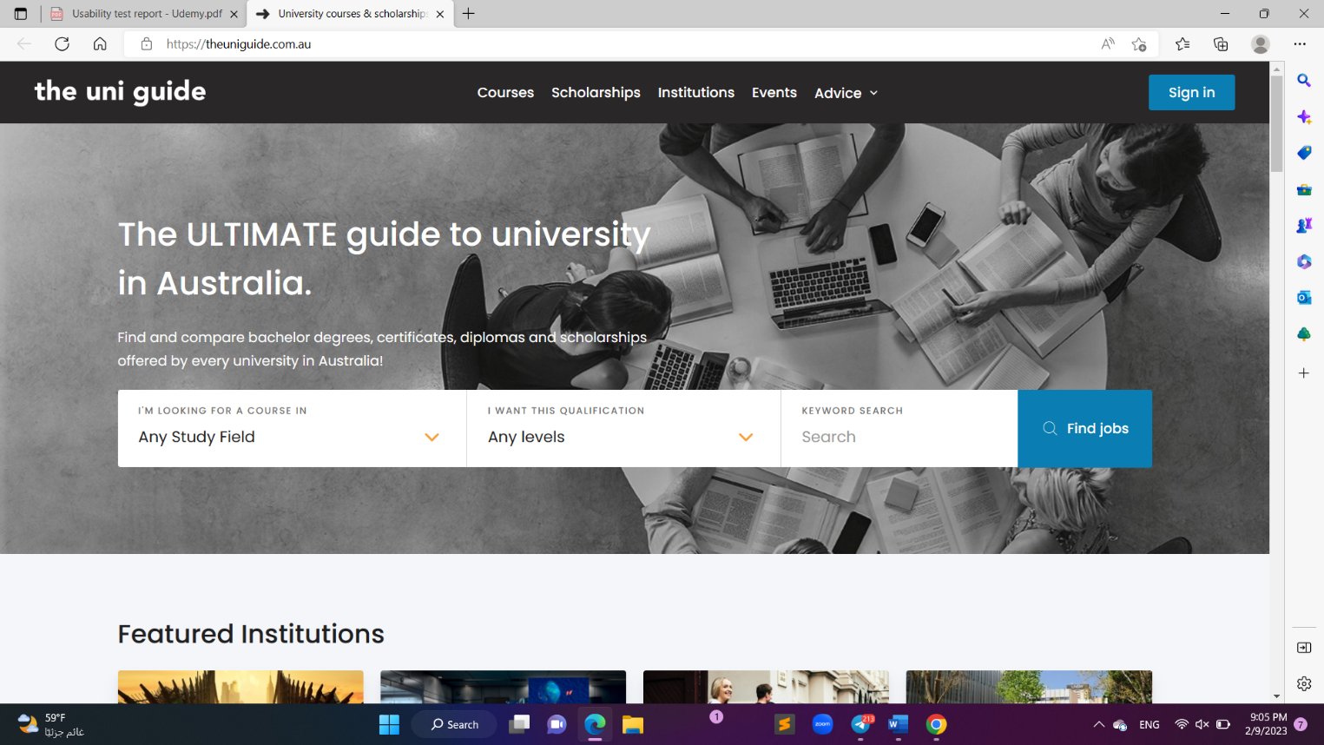

## Figure 13

1. Clear heading for each section.

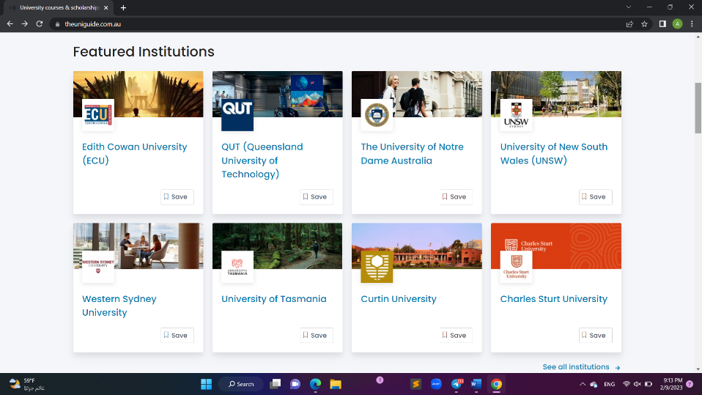

## Figure 14

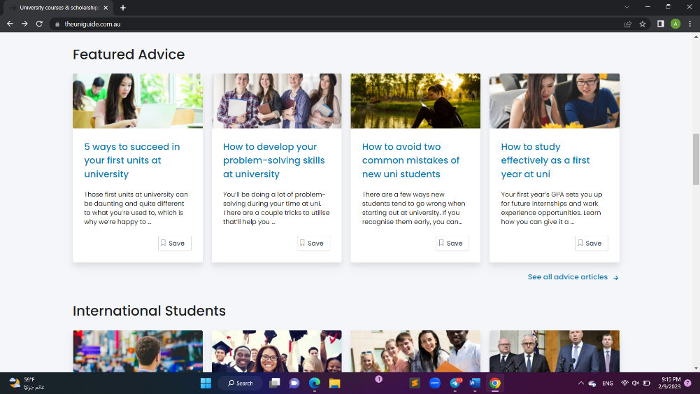

## Figure 15

1. Users can refine the result for their search.

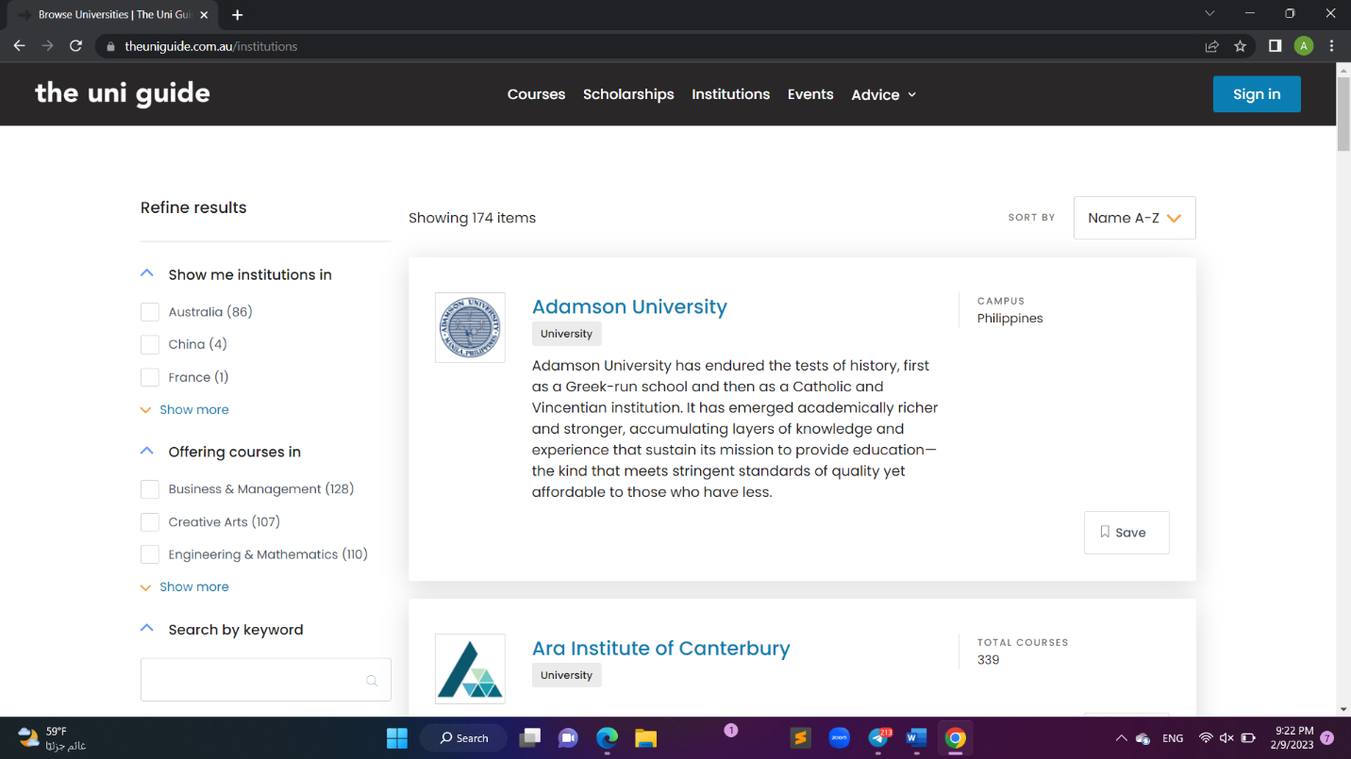

## Figure 16

1. There are various ways to register the account, and the user can open his account using the LinkedIn account as well.

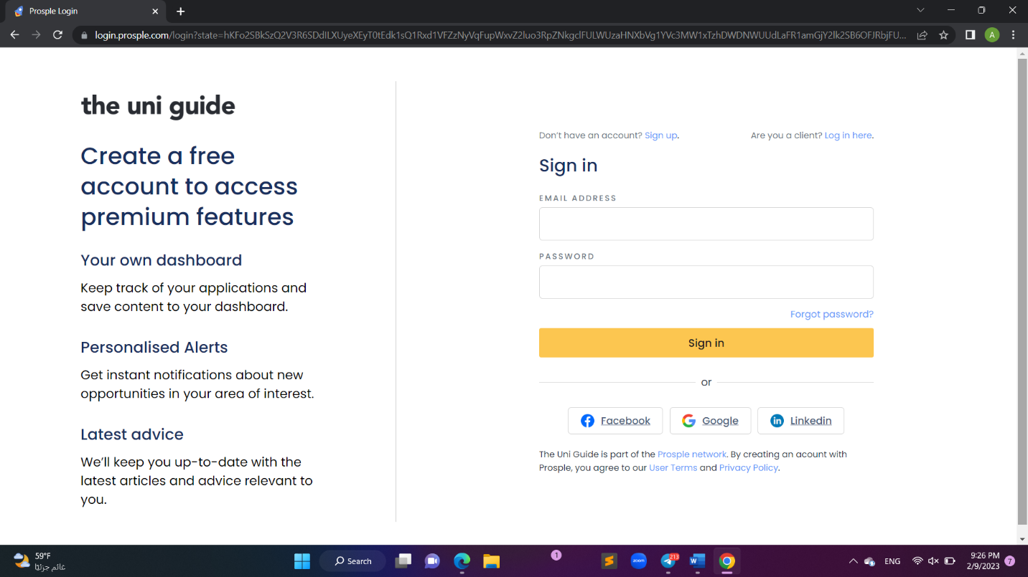

## Figure 17

**4- Fourth system: <https://sites.google.com/view/ccsitguide/home>**

1. The homepage navigation bar contains the most frequently asked questions and contact details which makes it easier for the user to understand the website and how to access it, but the color of the navigation bar items is not clear and not easy to see.

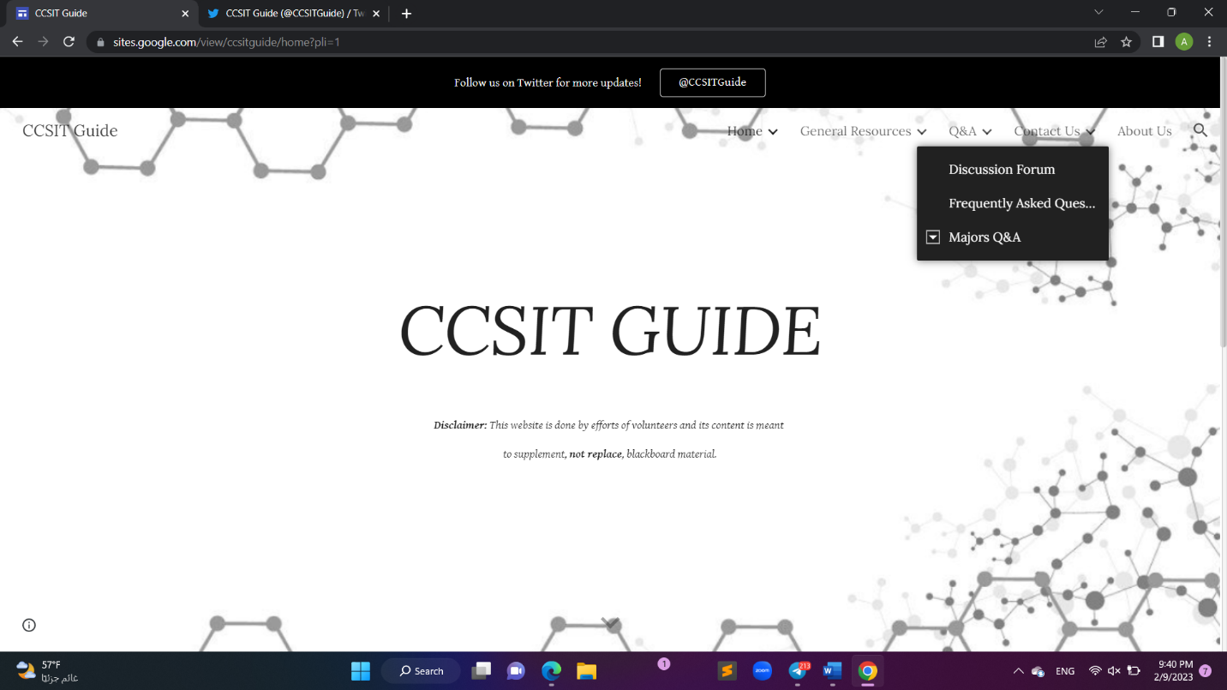

## Figure 18

1. Clear division of all levels.

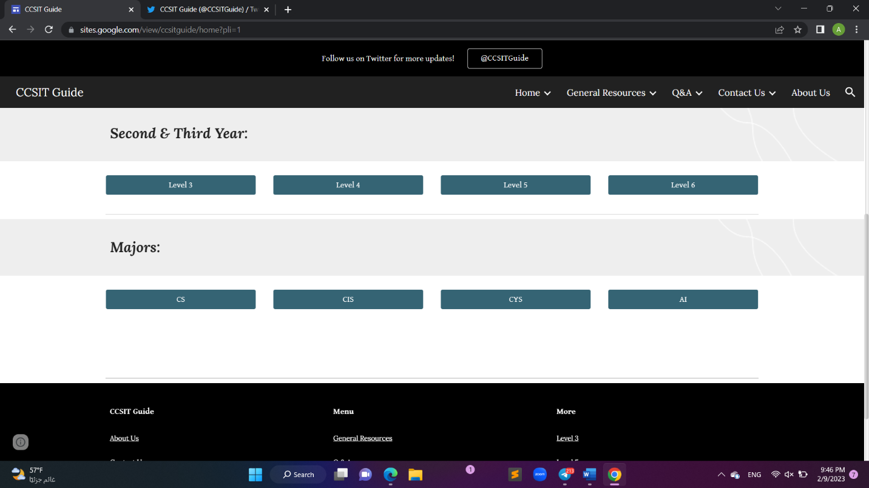

## Figure 19

1. Each section has a great page design and includes all the blogs and files for each course.

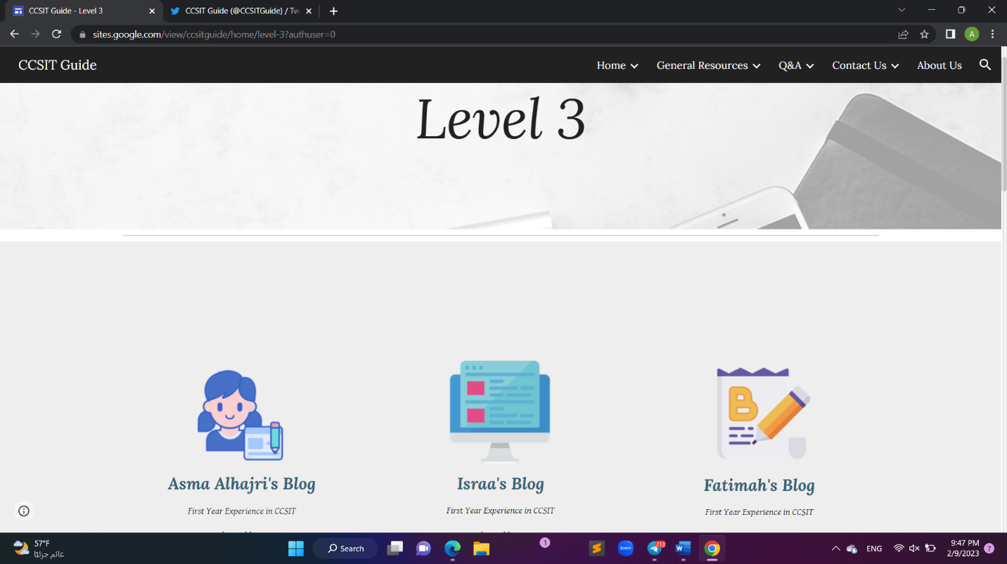

## Figure 20

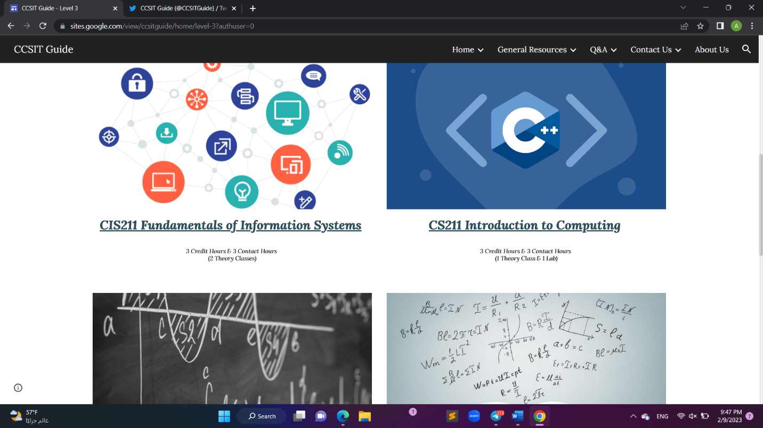

## Figure 21

**5- Fifth system: <https://www.wiziq.com/>**

1. Homepage with a wonderful and distinctive design.

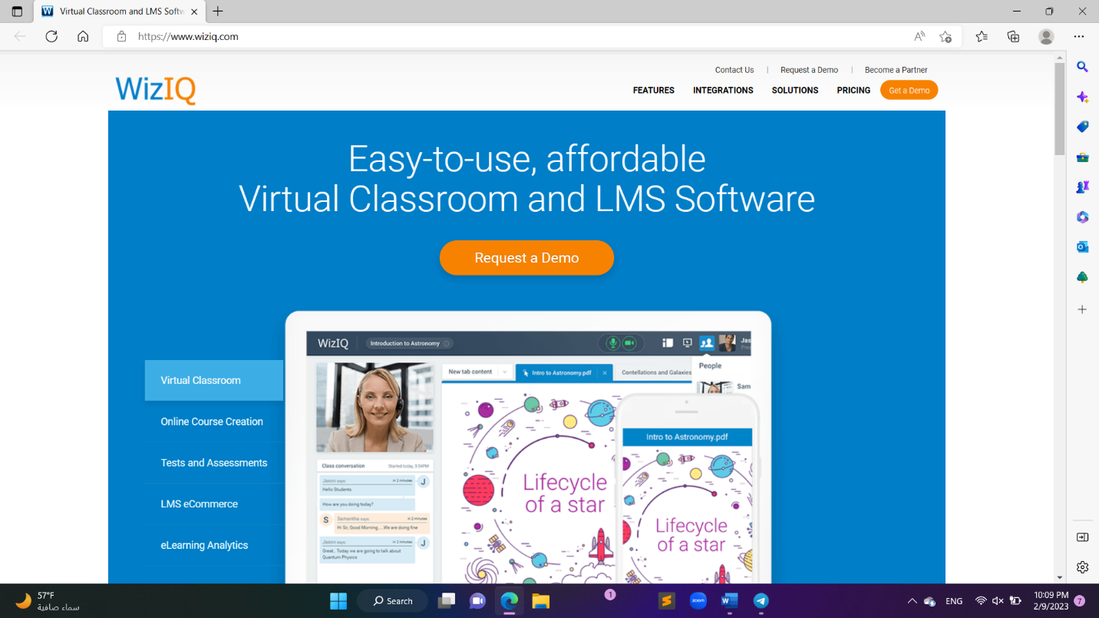

## Figure 22

1. A clear explanation of the idea and content of the site.

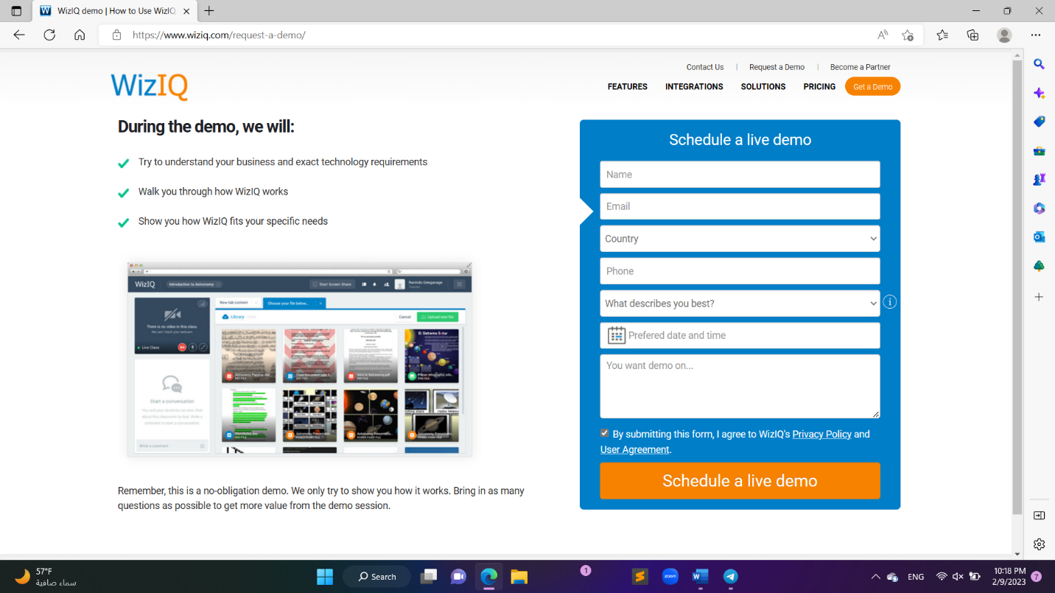

## Figure 23

1. 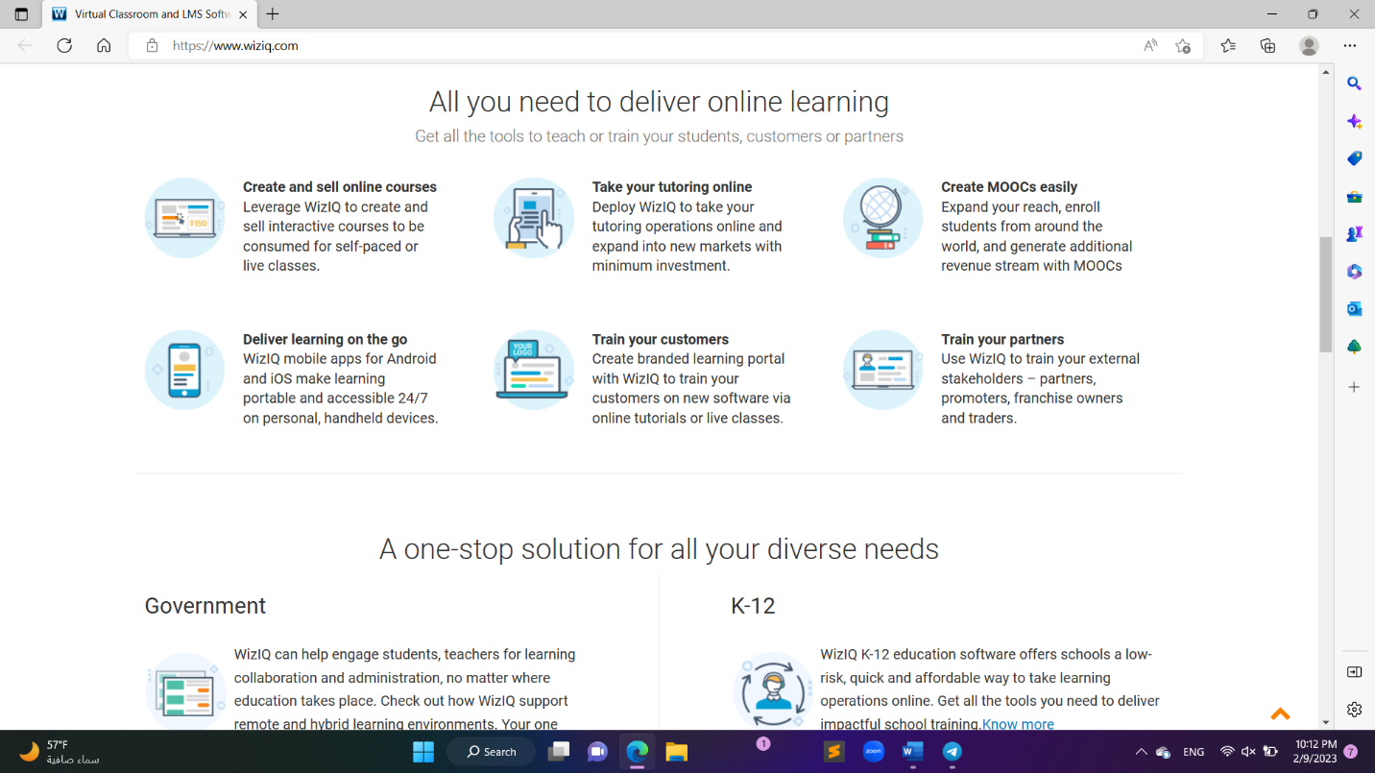User can request for live demo, and they show him how it works, schedule live demo form:

## Figure 24

1. Accessing virtual classroom.

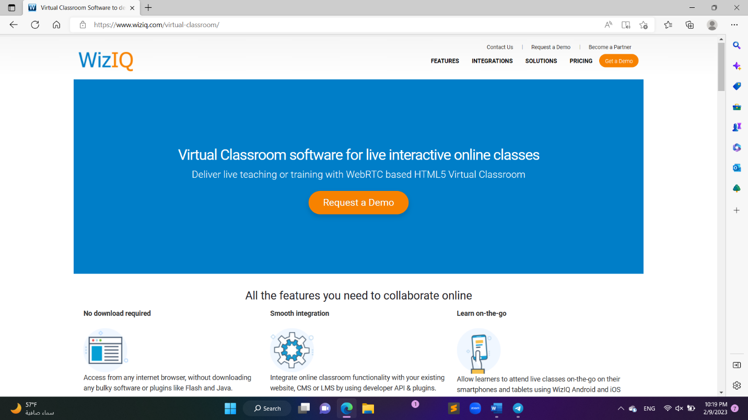

## Figure 25

**The important usability characteristics of user:**

1-Accretion user’s need:

The applications anticipate the good functionality to match the user need of performing so the user won’t reject it. In addition, each applications consider the students act whether for commonly or occasionally tasks and subtasks.

2- reliability:

The websites ensure the reliability by reflecting the actual data of the database to the users. Furthermore, each link in each website is navigate to the expected destination for example when the user press on the courses icon it will navigate the user to the courses page not to the contact page.

3- Speed of performance:

The performance requirements define how well the software system accomplishes certain functions under specific conditions. At the same time the execution time is an important factor must be noticed which is that’s what is fulfilling by each app.

**The important usability characteristics of tasks:**

1- Integration:

The websites ensure the Integrality by allowing the user of being able to run across different software tools and packages, for example Edmodo application can run on iOS and android. Also, each website can be open through different search engines like: Google Chrome, Safari, internet explorer and Firefox.

2- Portability:

Each app ensures the availability of data navigating among different software by providing the copy, paste, and cut features to transfer data and hardware like laptop, PC, and portable devices such iPads and phones.

3-Consistency:

Each website provides different way of filling spaces for every data input and achieve the consistency by having each field next to each requirement such as text input must take text field, password input in password field.

# **User analysis:**

1-Customization:

The user can control the sizes of the icons or the size of the font that appears in the timeline, whether large or small. There is a choice of night or day mode in terms of brightness. The user controls what suits him and what makes him able to enjoy

2-Notifications:

The main function of notifying the users is to remind them of all the events and courses in which they are participates in. Moreover, in our system the option of receiving notification would inform the students of all the interested announcements, like if the student majored in CS will receive all the courses updates and more about it as notifications to keep being updated in all the times by what they are really care about.

3-Personalization:

In our system we tried to ensure the process that creates a relevant, individualized interaction between two parties designed to enhance the experience of the recipient through tracking the most existed and interested thing and show related topics to the same thing such as, ads and announcements.

4-Search:

We focused on facilitating the search process by providing the search bar for the students, so that when they want to search a specific topic this will be the guide. Also, as an element of error prevention and concerning the requirement we provide the auto-completion for completing the student search before the end writing, this feature is optional based on what the student desired will appear, to allocate the topic the want easily.

5-Instructions:

The meaning of the instructions here is that a skippable page appears for the newly registered user of the application. We show him the components of the application and explanations for some icons and how to browse and navigate, which gives him ease and speed to learn the application.

6- Reliability:

To accomplish the reliability goal in our application we do create a strong research design, choosing appropriate methods and samples, and conducting the research carefully and consistently. Also, ensure the real reflection of data, the right navigating and operate in a defined environment without failure.

# **Task analysis:**

The website provides the user with several clear and easy-to-use tasks that facilitate dealing with the website, including:

* View the timeline.

Where the user can view the timeline, which contains the latest posts of other users, and like or interact with them.

* Create a post.

It allows the user to create their publications and share their experiences and knowledge.

* Navigation bar.

The navigation bar will appear for the user to provide quick access and ease of navigation, through which he can access the home page, search for the required content, go to the notifications page, and also an option to access the direct message page, and it contains many tasks that are frequently used.

* Tasks for the user page:
* Joined activities:

This function helps the user to access the activities in which he participates.

* Orders:

It contains the functions of creating/canceling orders, which enables the user to create or to have a new order, also, he can cancel existing orders.

* Likes and replies:

It shows all the likes on the page and all the students’ interactions and comments.

* We have several “setting” options:
* Search settings It allows you to search for the required settings directly.
* It will help you to move to the account setting page to see information about your account, download an archive of your data, or learn about your account deactivation options.
* Check out to get useful Information to learn more about the platform's products services.
* And you can access to change settings faster and easier.
* The user can convert the platform’s accessibility, display, and languages manage how content is displayed to you.
* The user can select the kinds of notifications you get about your activities, interests, and recommendations.
* Easily Manage your account's security and keep track of your account's usage including apps that you have connected to your account.
* Privacy and safety manage what information you see and share on the platform.
* Users can easily log out from the account.
* Advertisements will be displayed to the user professionally by private tutors, through which the user can choose and communicate to create a request.
* You can search in DM; it allows you to search for a specific student or group.
* You can also create a group of several users, and each user can participate and send messages.

# **Paper prototype (Balasmiq) [3]:**

Web pages [4]:

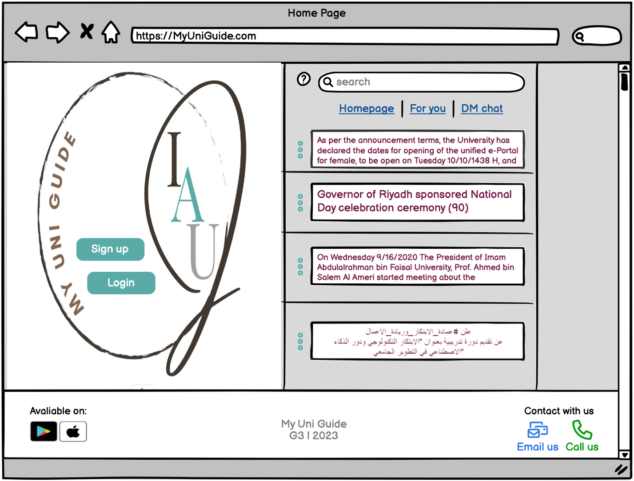

## Figure 26: Home page

The homepage is the first site the students will open it’s same as a welcoming page where there few features such as keeping up the new news through the timeline, search bar, reaching the direct message chat and more. In addition, represented to excite the new students to join in by signing up and for the preeminent students they can join their accounts by logging in.

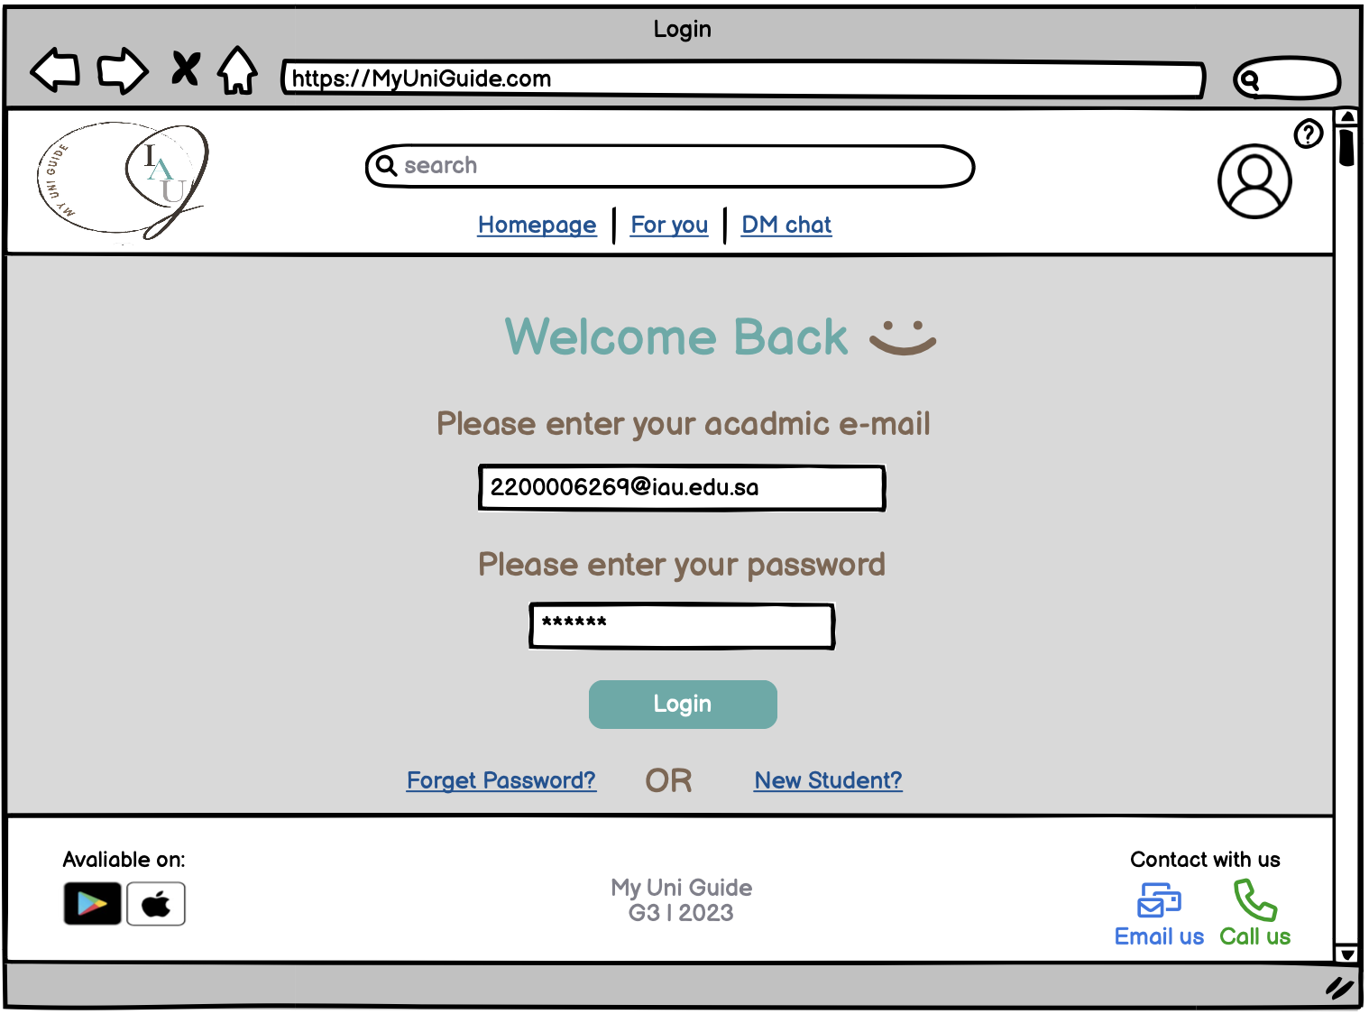

## Figure 27: Login page

Allow the students to enter the own account by using the academic email and password.

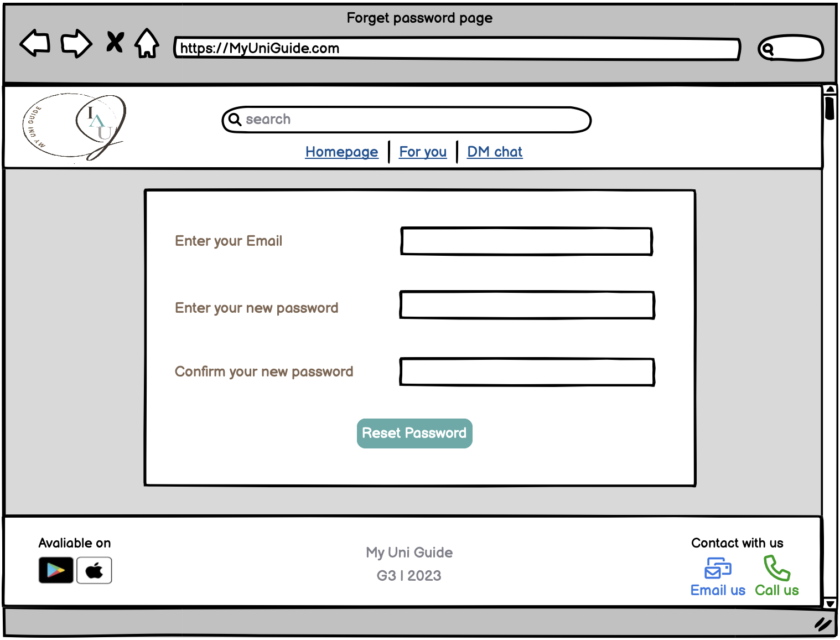

## Figure 25: Forget password page

Allows users who have forgotten their password to reset their passwords in order to unlock their accounts. By entering the email address associated with the account. Once the account is verified the user can set a new password and confirm it to ensure that the password has been entered correctly.

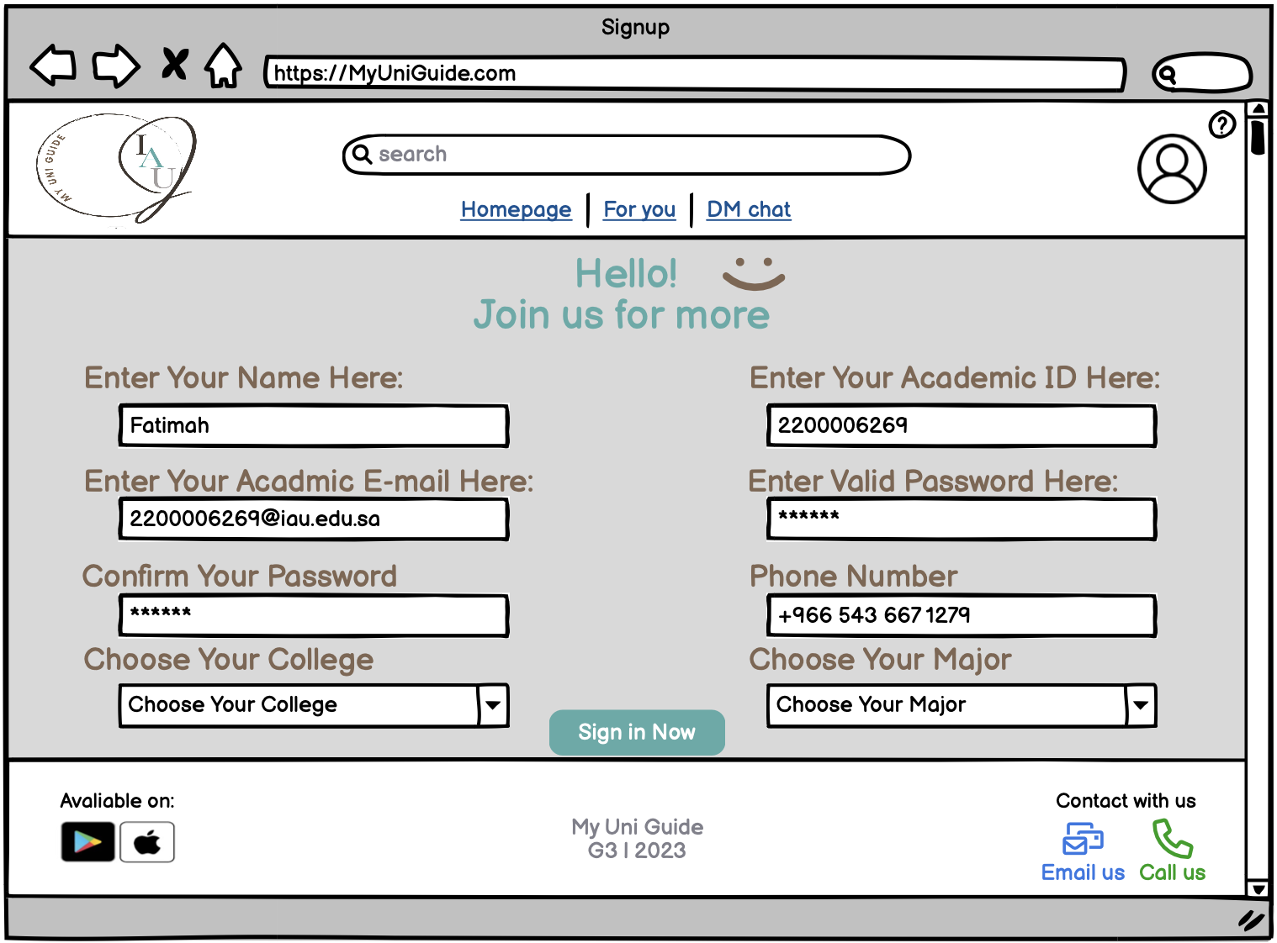

## Figure 26: Signup page

Allow the student to create a new account by filling the fields requirements.

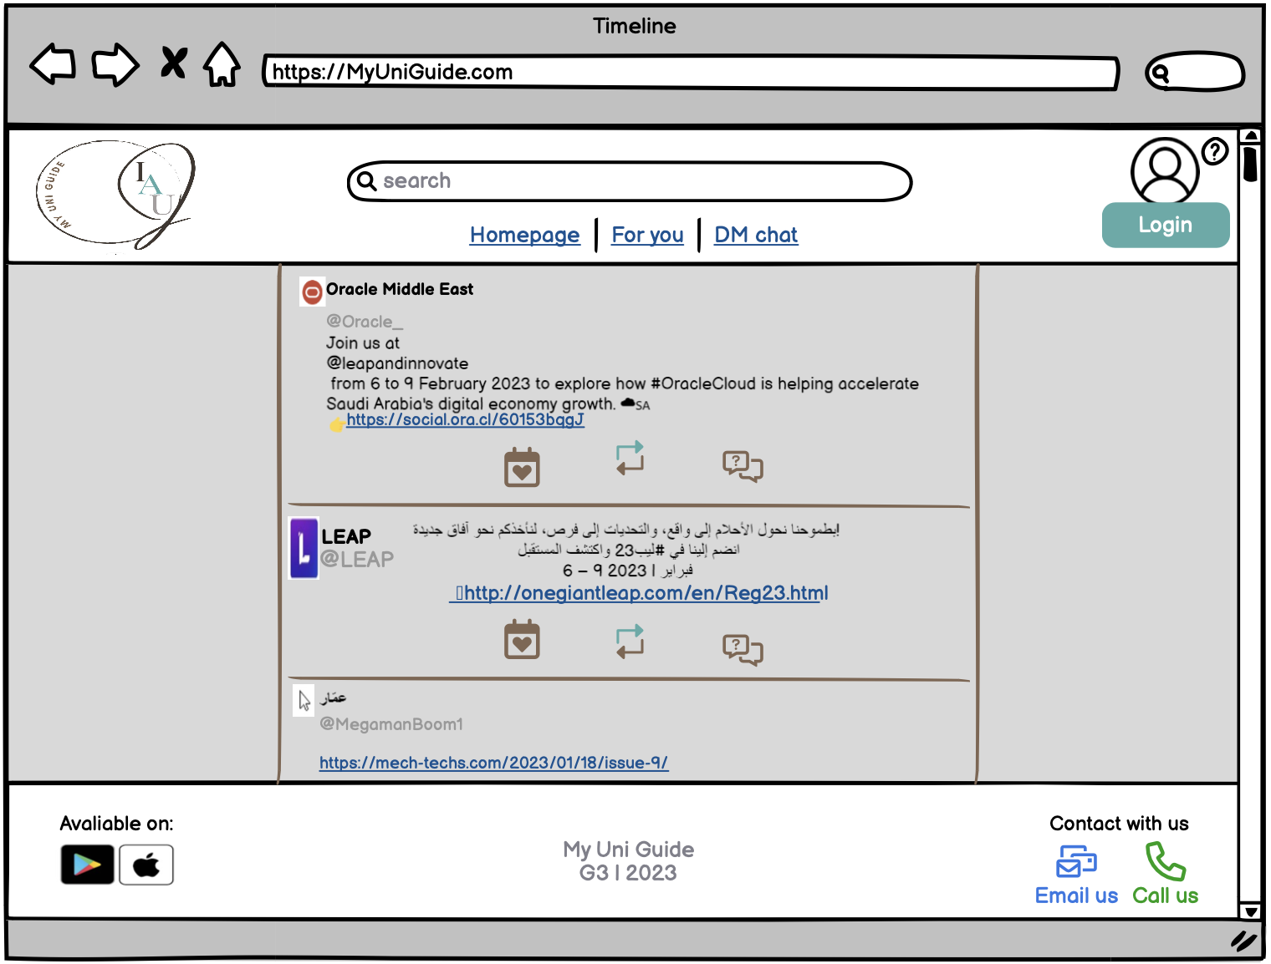

## Figure 7: Timeline page

The main page of our application where every student can view most events that they interested with or not and reach the rest page from.

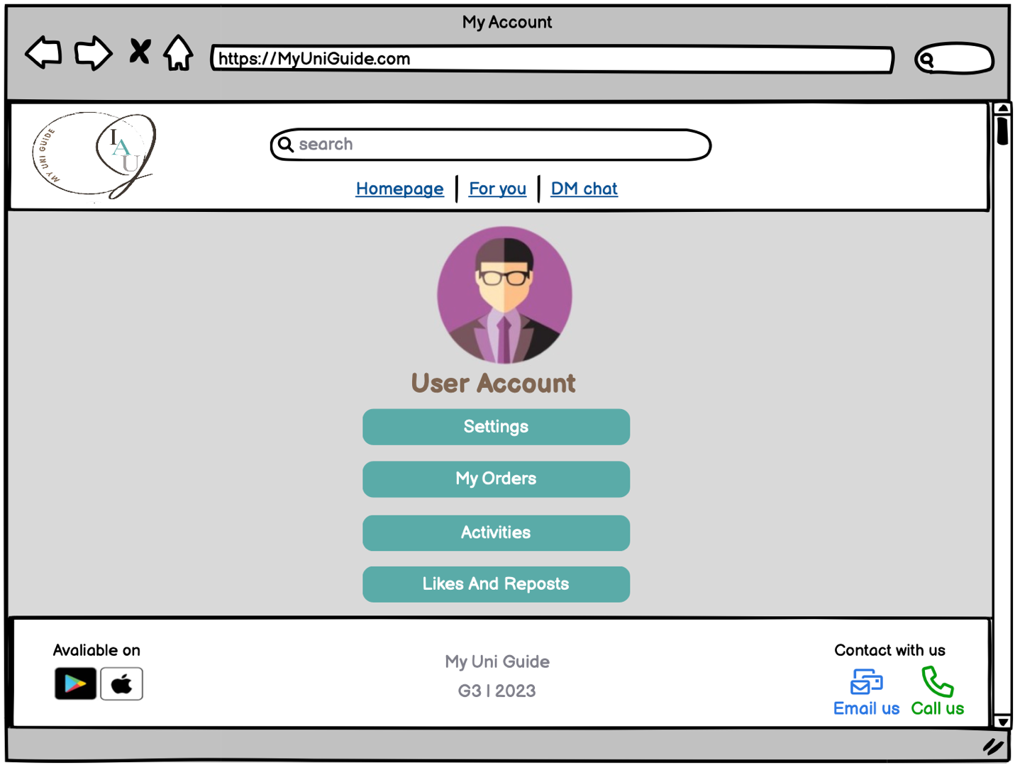

## Figure 8: User account page

This account page allows some options for such settings, requests, events, and likes and replies.

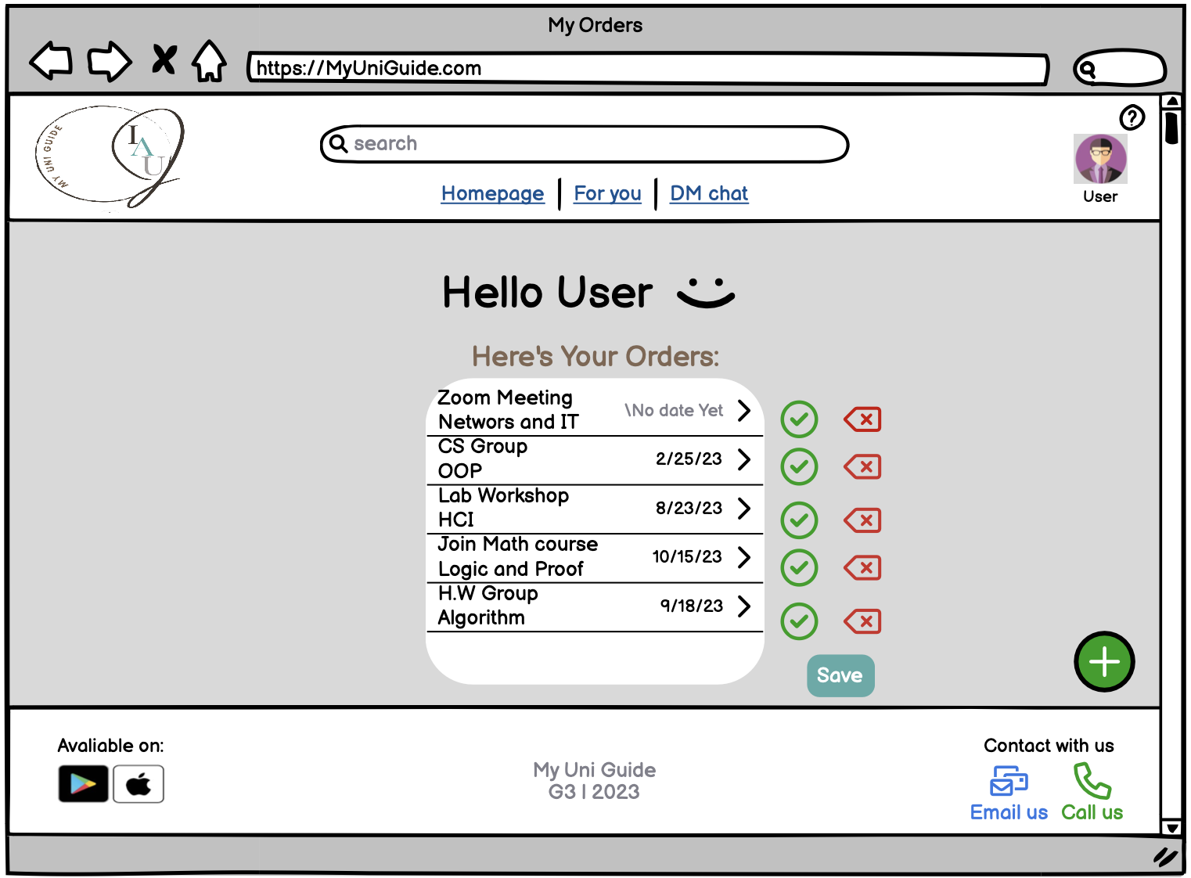

## Figure 9: My orders page

In this page the user is able to make orders, arrange it and even cancel if it’s necessary anymore.

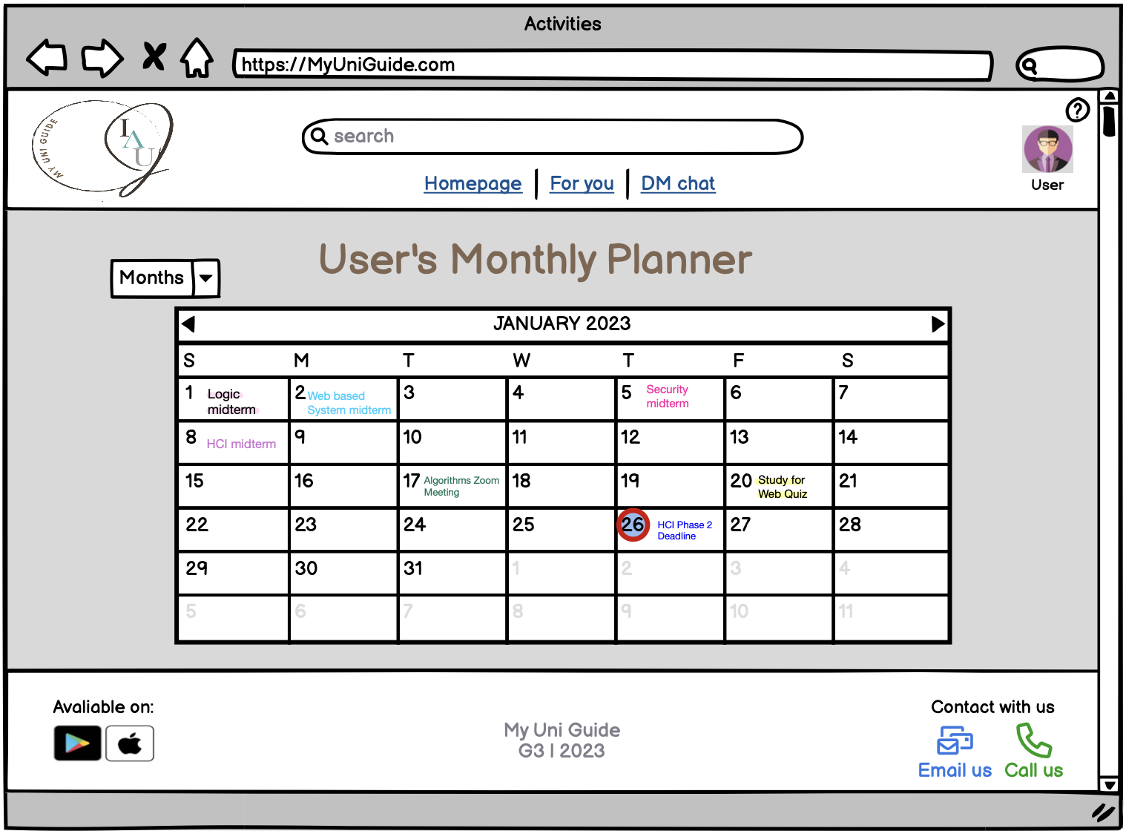

## Figure 10: Activities page

In this page each student can be able to schedule and make note of their own joined activities through a monthly calendar day by day.

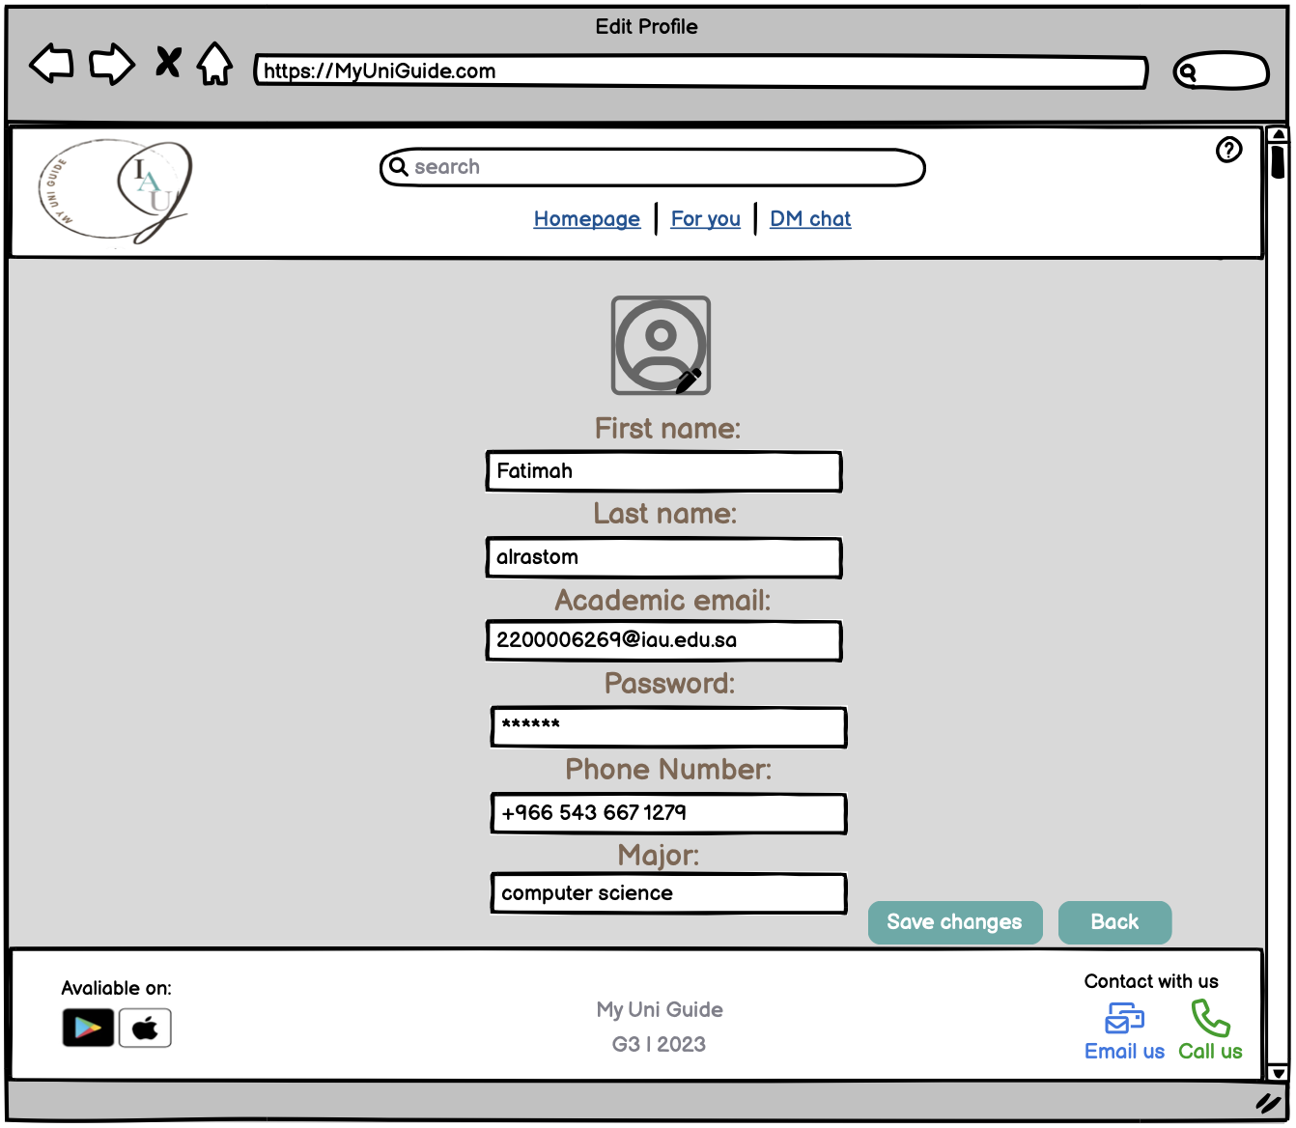

## Figure 11: Edit profile page

This page allows the user to modify his information that he entered during registration, for example: changing the major if the student changes his academic major.

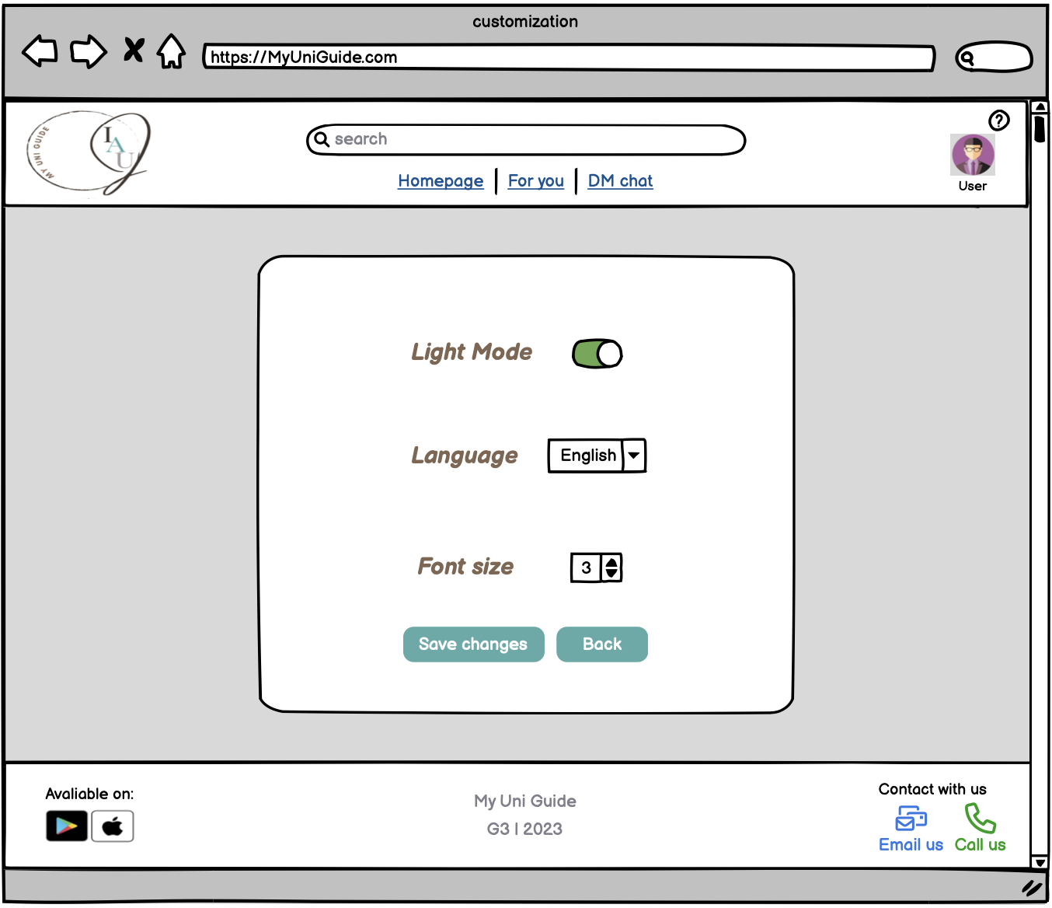

## Figure 12: Customization page

This page gives the user the options to change the settings of the pages and the language of the site.

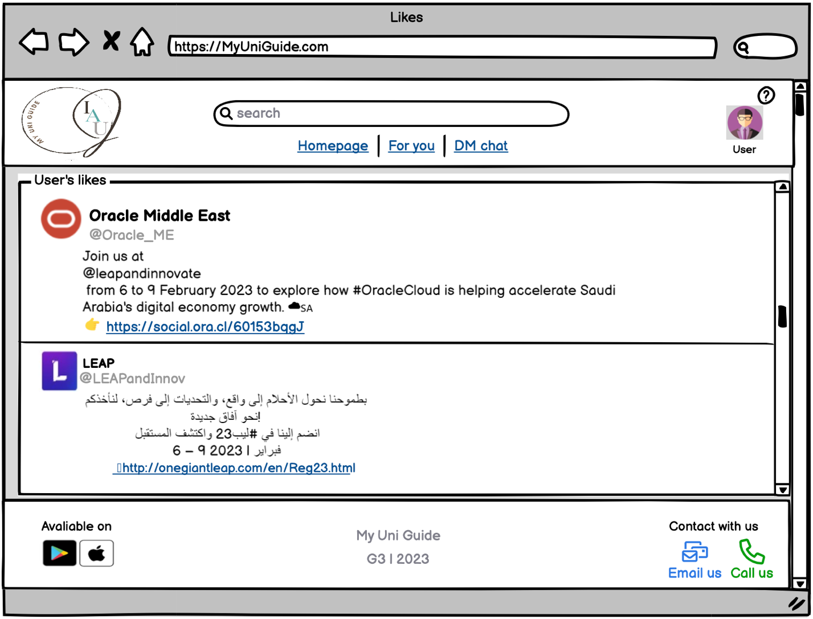

## Figure 13:Likes page

Shows on this page the publications that the User liked while browsing the Timeline page.

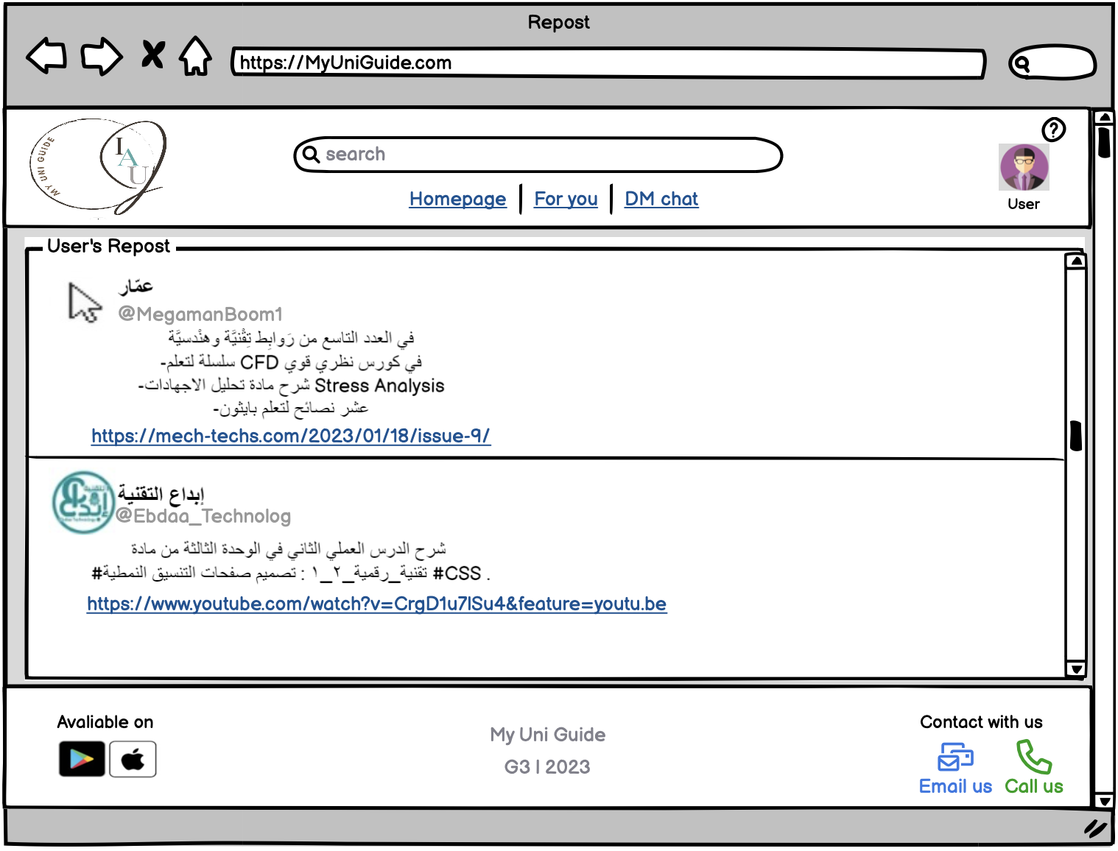

## Figure 14: Repost page

On this page the posts that the user has reposted while browsing the timeline in his account are displayed.

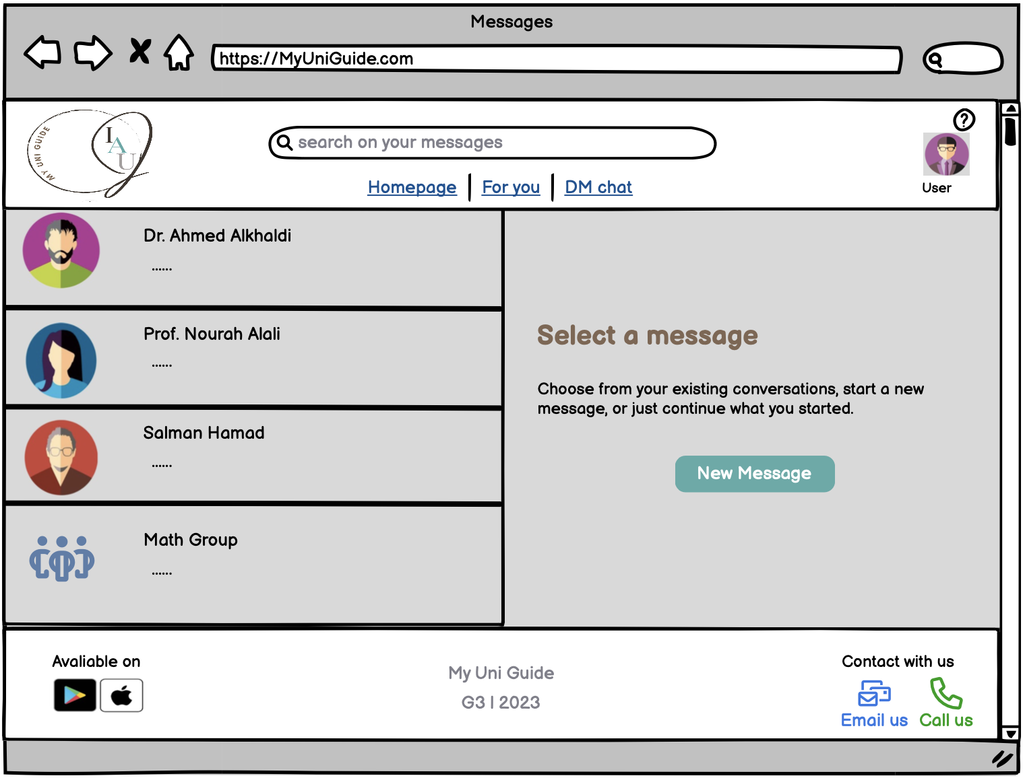

## Figure 15: Messages page

This page shows you the contact and the people you communicate with, it shows you the messages, also you can create a new chat with a new contact, then it will take you to the conversation of each person you have, and you can use the voice and video call feature.

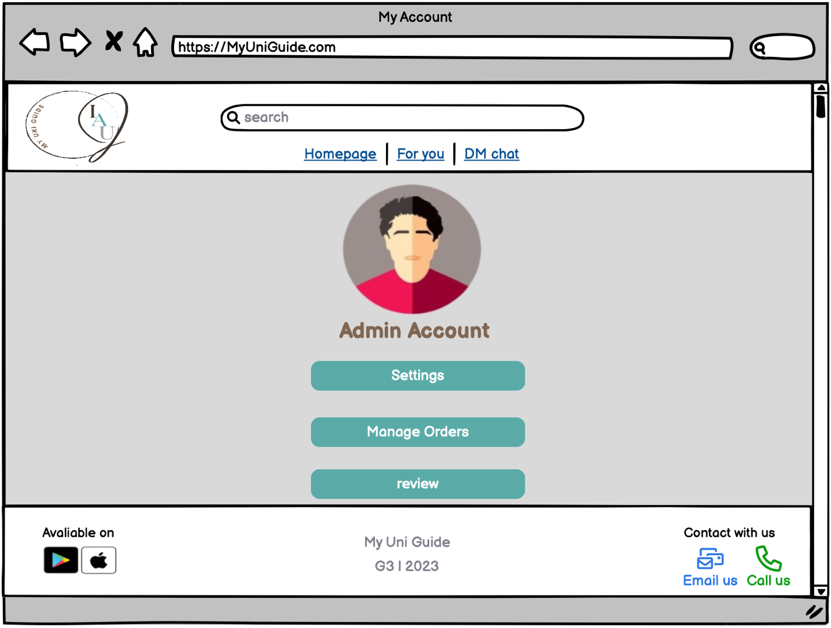

## Figure 16: Admin account page

This admin page allows some options such as settings, managing orders and review.

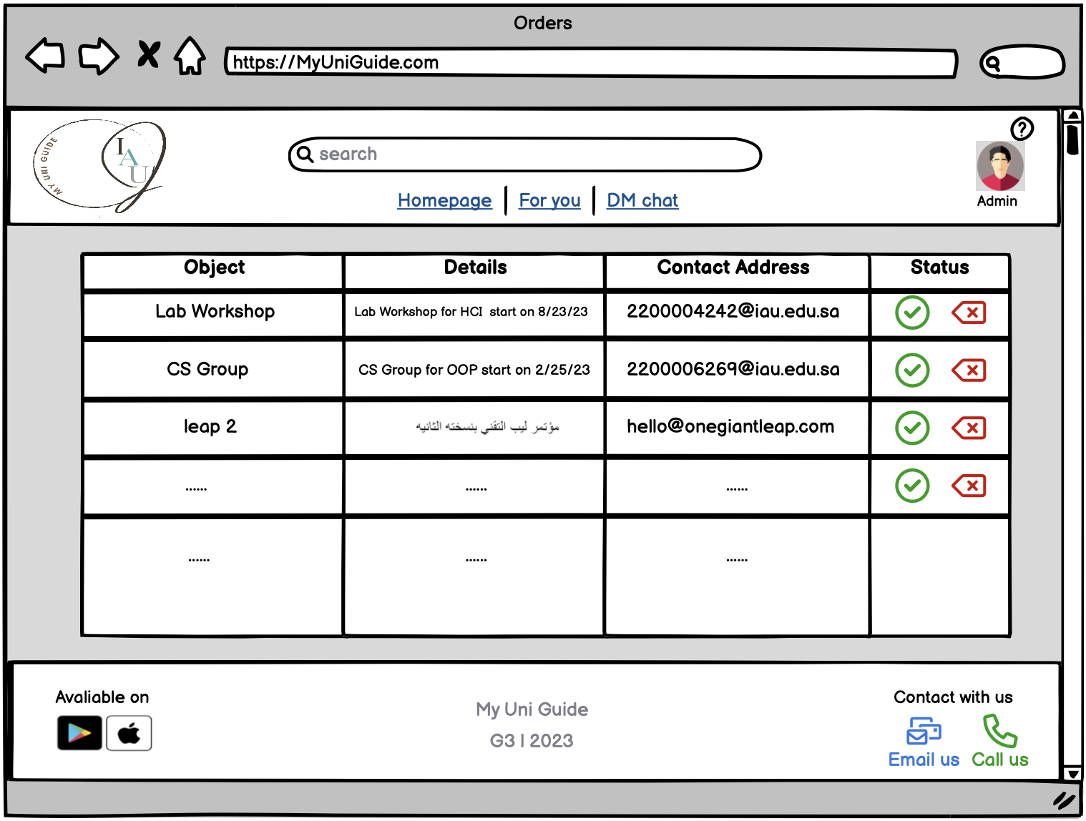

## Figure 17: Orders page

In this page the admin can review all the orders that the users provided then approve it or reject it.

Phone Pages [5]:

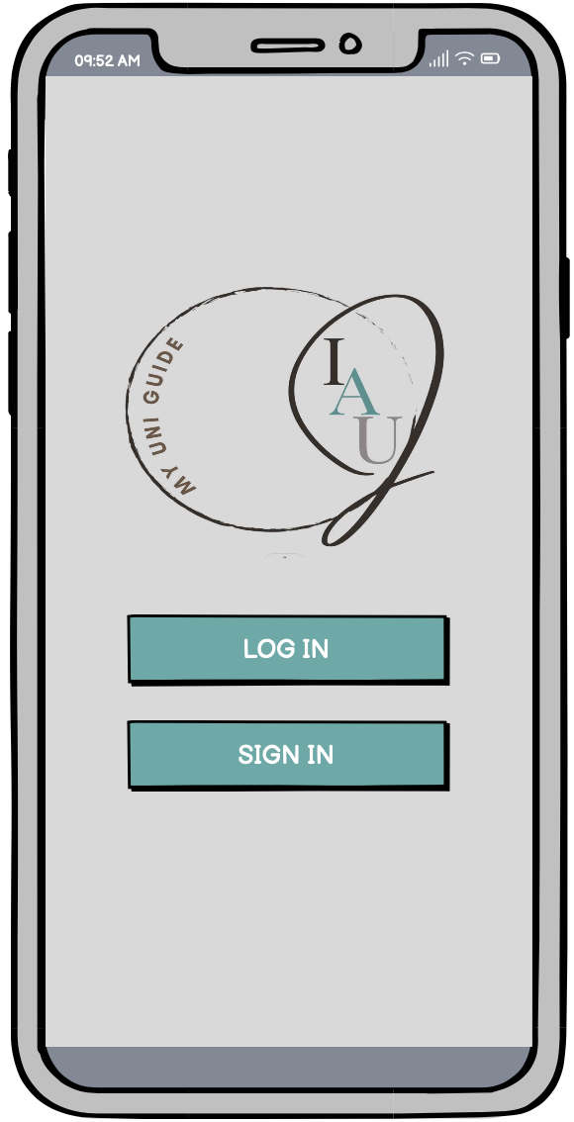

## Figure 18: Home page

The homepage is the first site the students will open it’s same as a welcoming page where there represented to excite the new students to join in by signing up and for the preeminent students, they can join their accounts by logging in.

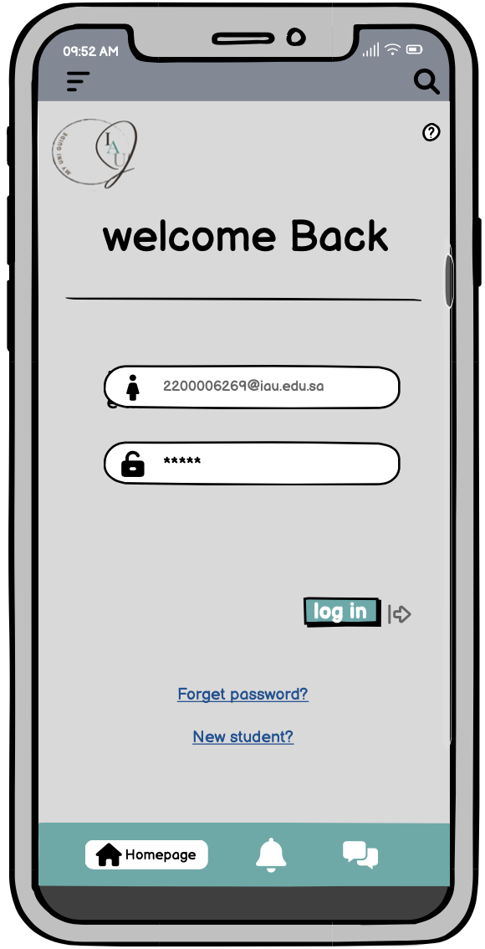

## Figure 19: Login page

This page will let you to log in your account by enter the email you used and password, then if u forgot the password, you could reset it or click on new student and create new.

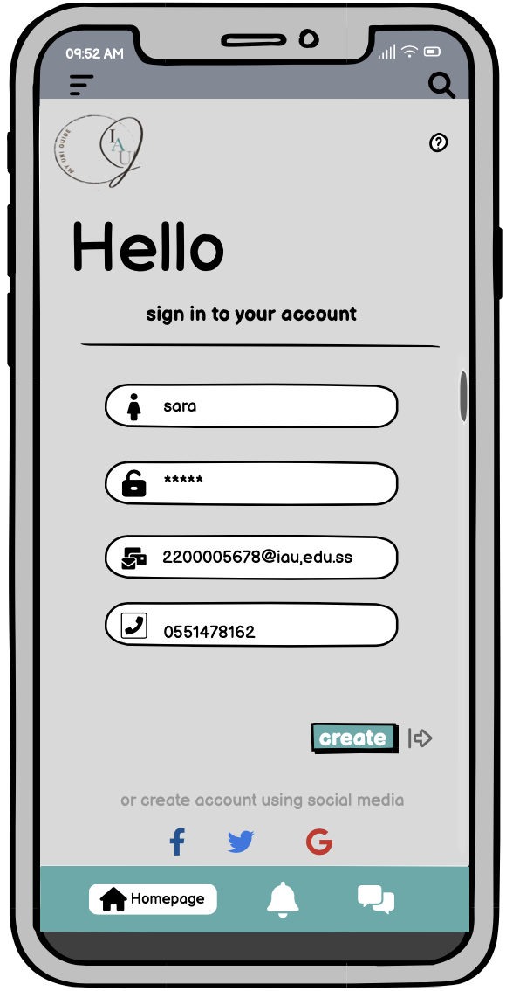

## Figure 20: Sign up page

Allow the student to create a new account by filling the fields requirements.

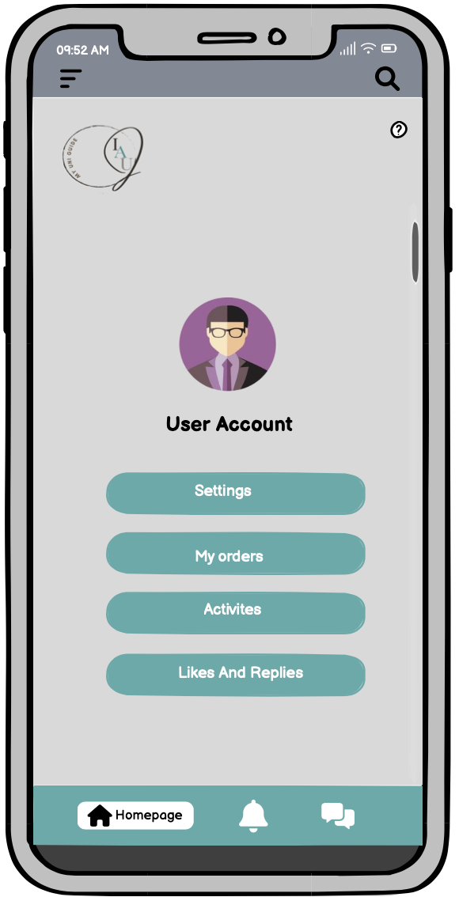

## Figure 21: User account page

‏This account page allows some options such settings, requests, events, and likes and replies.

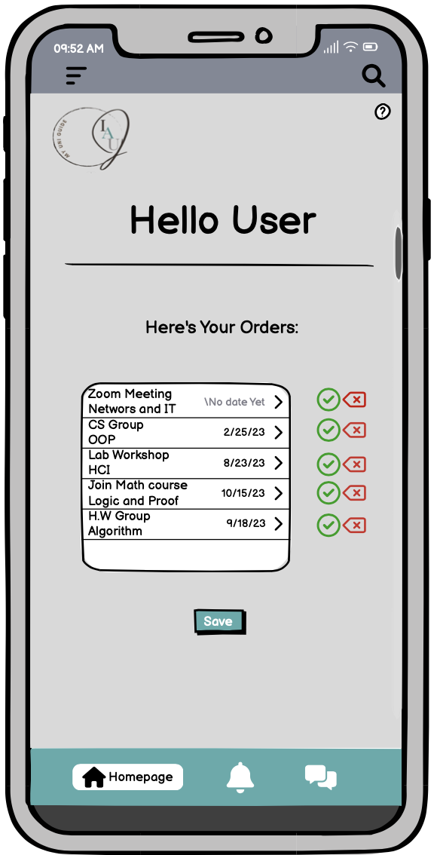

## Figure 22: My orders page

In this page the user is able to make orders, arrange it and even cancel if it’s necessary anymore.

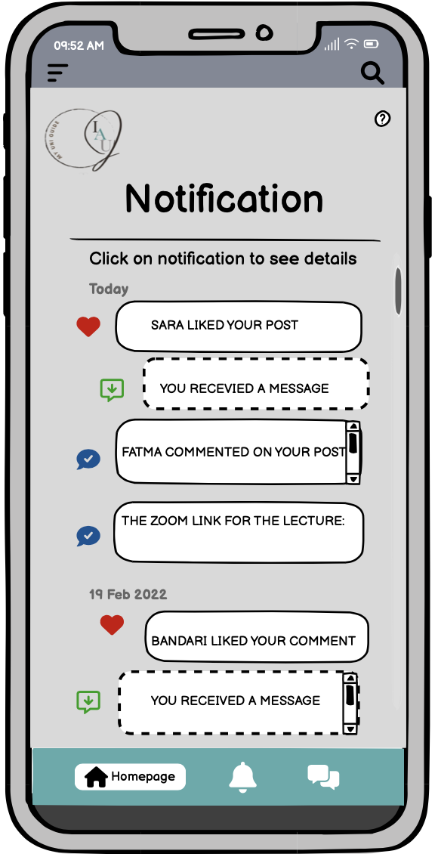

## Figure 23:Notification page

Will display all your notifications, likes, reply and comments you can click it.

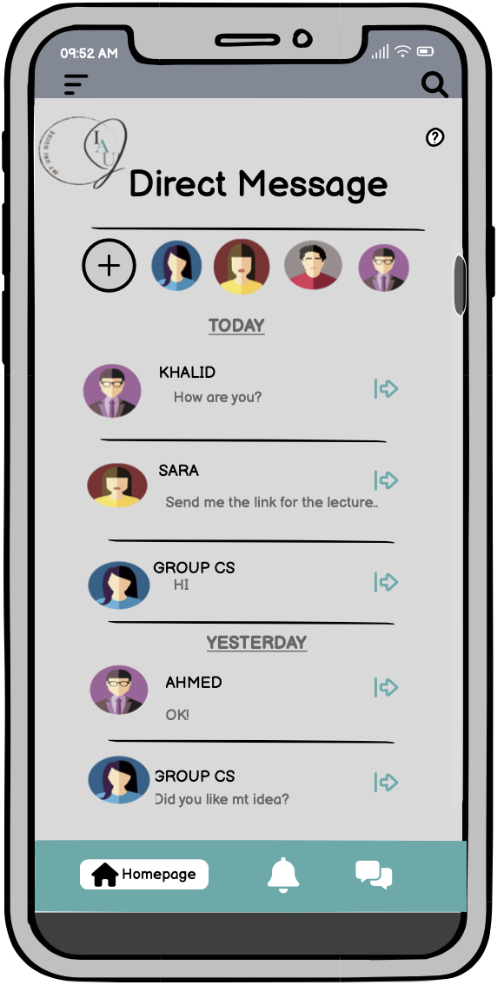

## Figure 24: Messages page

This page shows you the contact and the people you communicate with, it shows you the messages, also you can create a new chat with a new contact, then it will take you to the conversation of each person you have, and you can use the voice and video call feature.

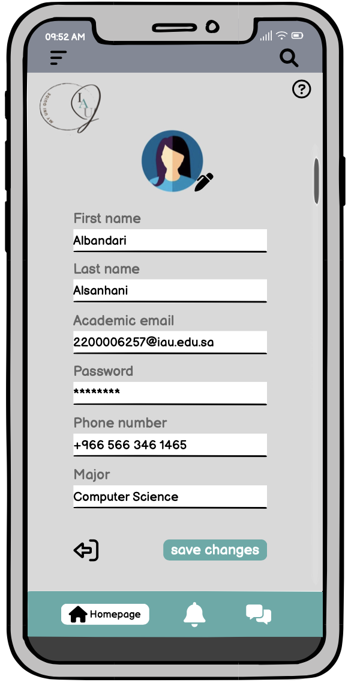

## Figure 25: Edit profile page

This page allows the user to modify his information that he entered during registration, for example: changing the major if the student changes his academic major.

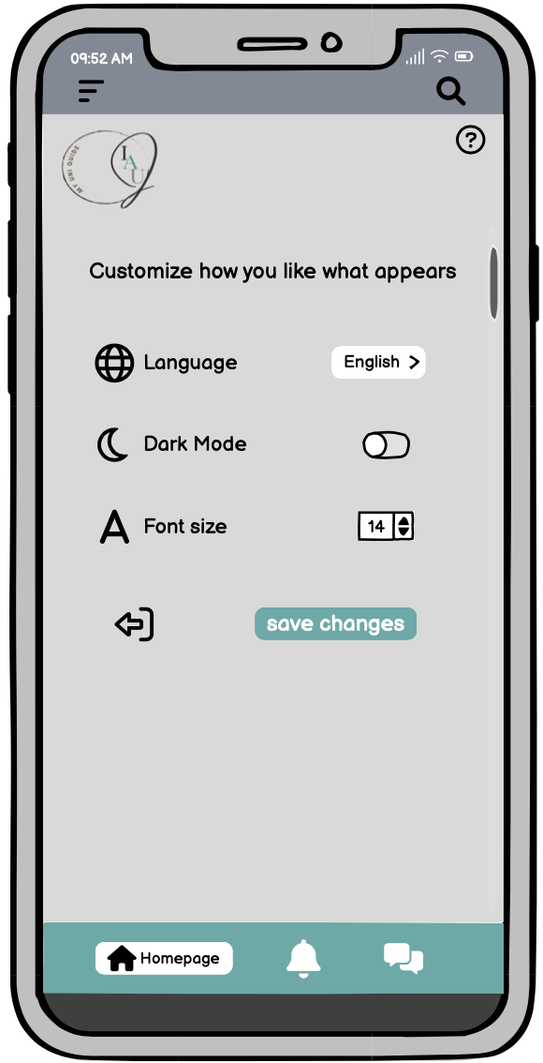

## Figure 26: Settings page

This page gives the user the options to change the settings of the pages and the language of the site.

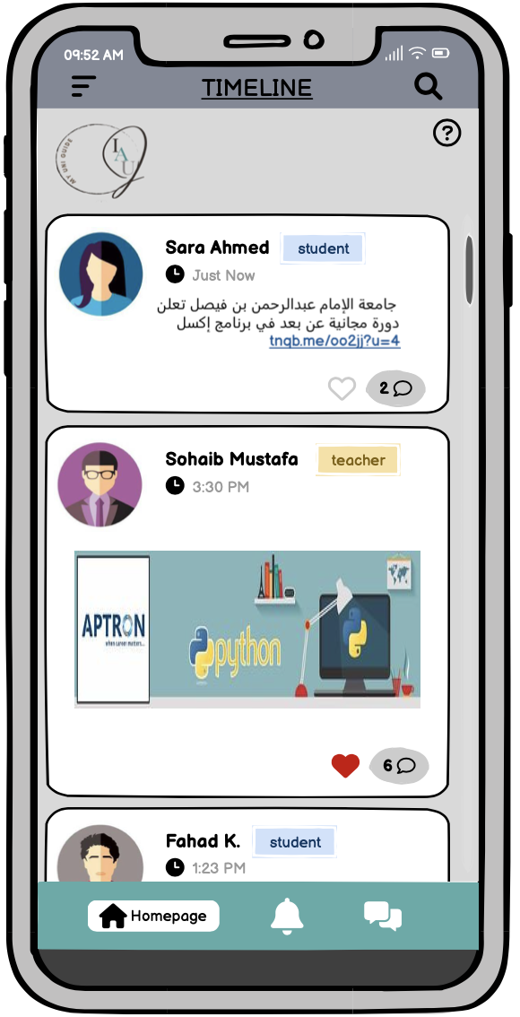

## Figure 27: Timeline page

The main page of our application where every student can view most events that they interested with or not and reach the rest page from.

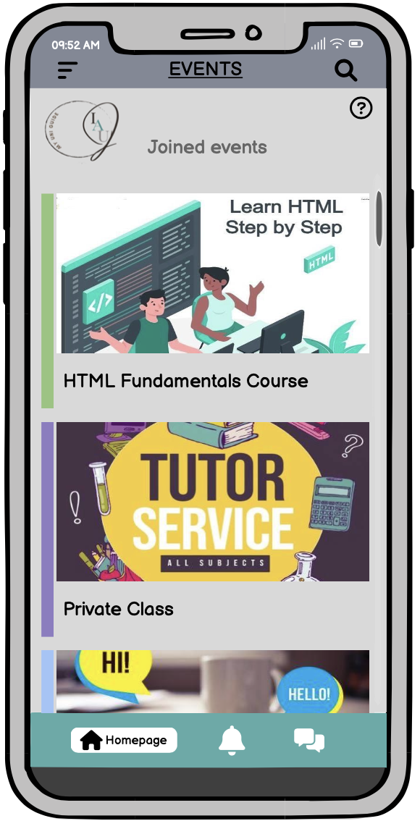

## Figure 28: Events page

In this page it will show all the events that the user has been joined to it.

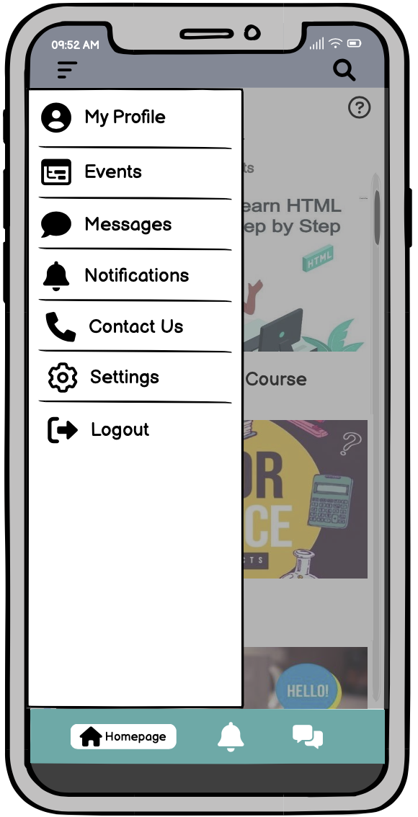

## Figure 29: Side bar page

The side bar will facilitate the navigation to the students to reach each of their profile page, events, messages, notifications, content us and the settings.

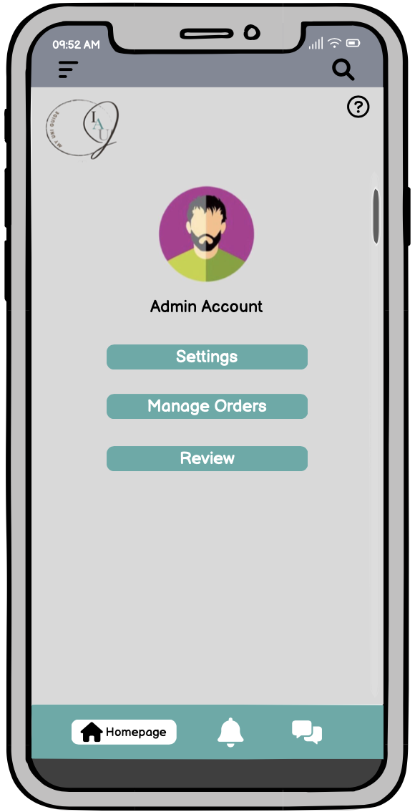

## Figure 30: Admin account page

This admin page allows some options such as settings, managing orders and review.

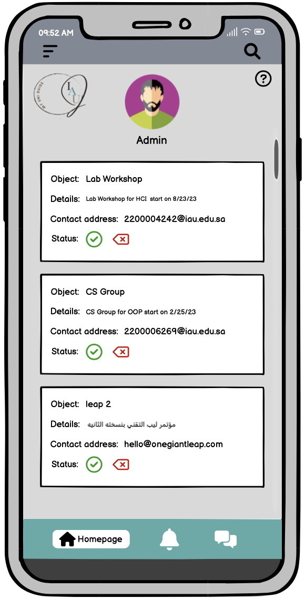

## Figure 31: Orders page

This page will display all the users’ requests with details and the option to accept or decline them.

# **Initial software prototype (Axure) [6]:**

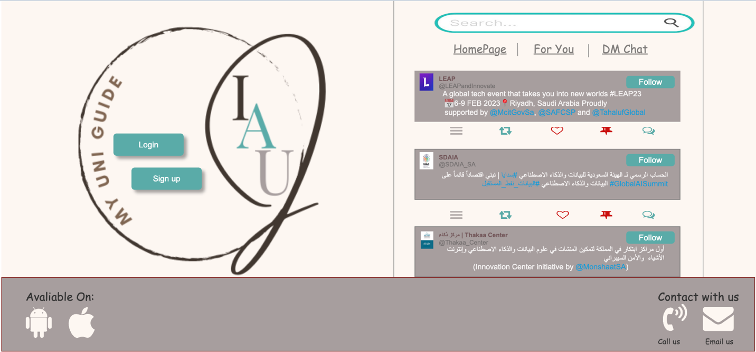

## Figure 32:Home page

The homepage is the first site the students will open it’s same as a welcoming page where there few features such as keeping up the new news through the timeline, search bar, reaching the direct message chat and more. In addition, represented to excite the new students to join in by signing up and for the preeminent students they can join their accounts by logging in.

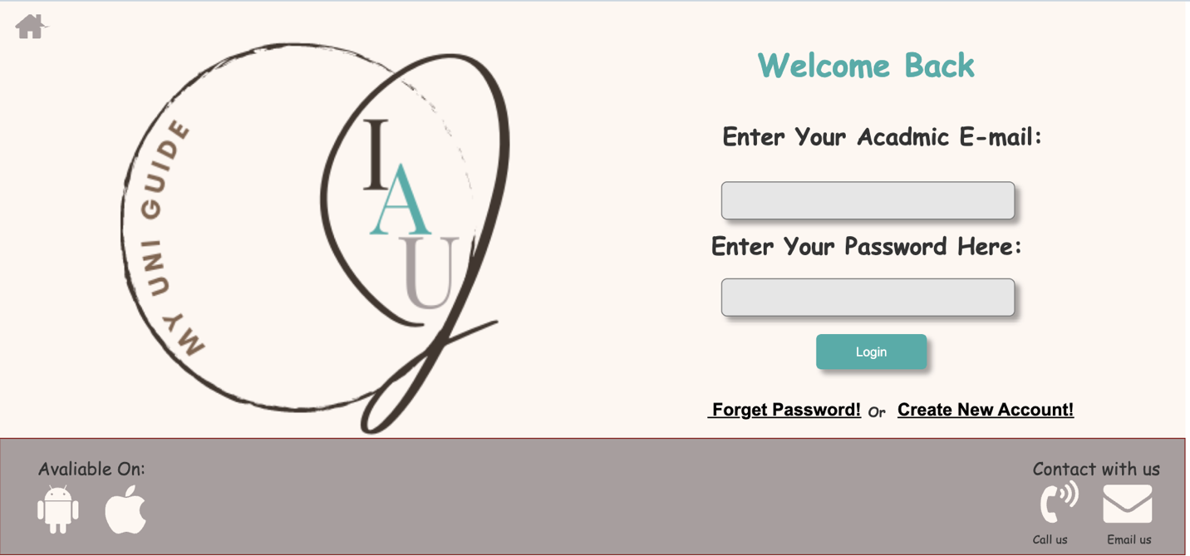

## Figure 33: Login page

Allow the students to enter the own account by using the academic email and password.

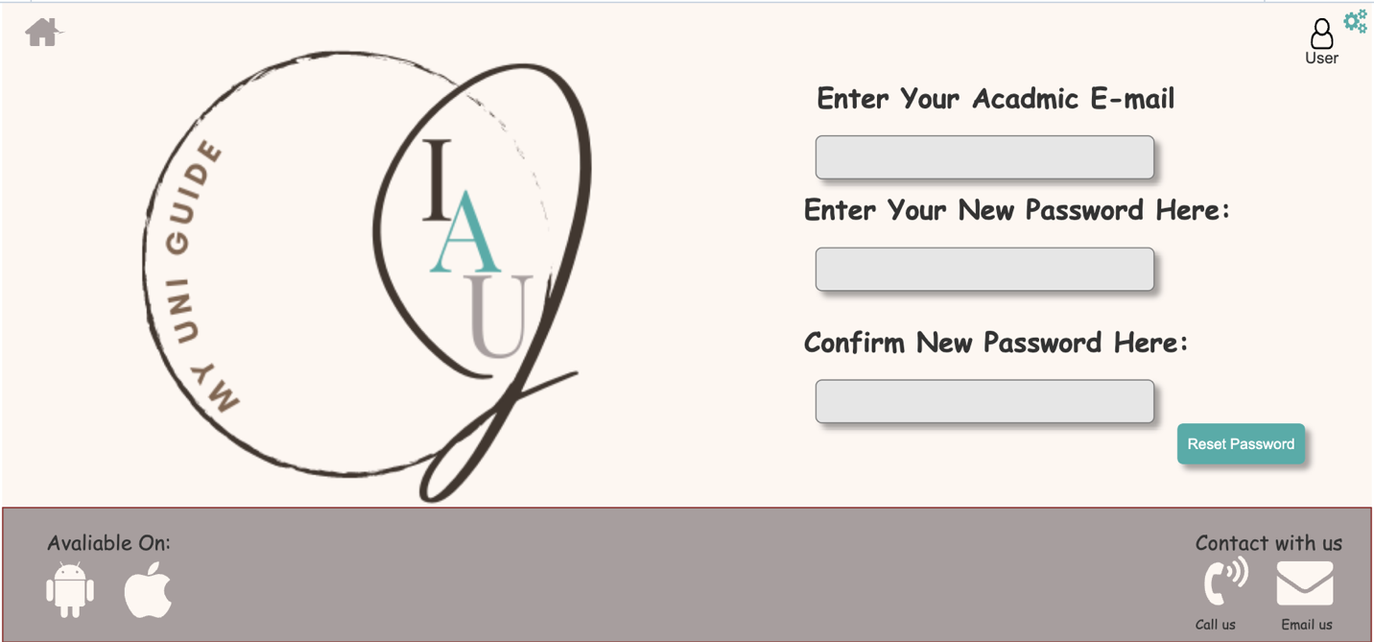

## Figure 34: Forget password page

This page allows the students to reset password if they forget it and want to login to their accounts.

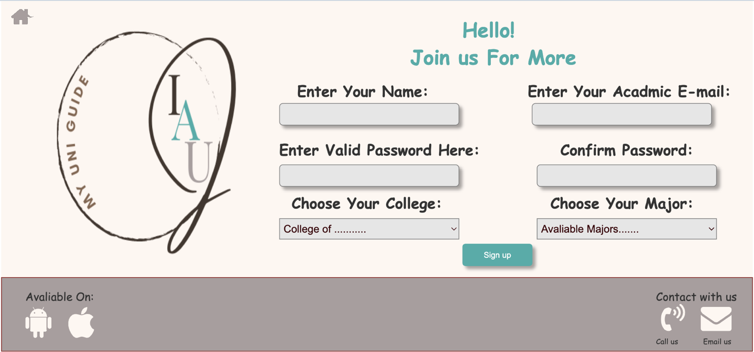

## Figure 35:Sign up page

Allow the student to create a new account by filling the fields requirements.

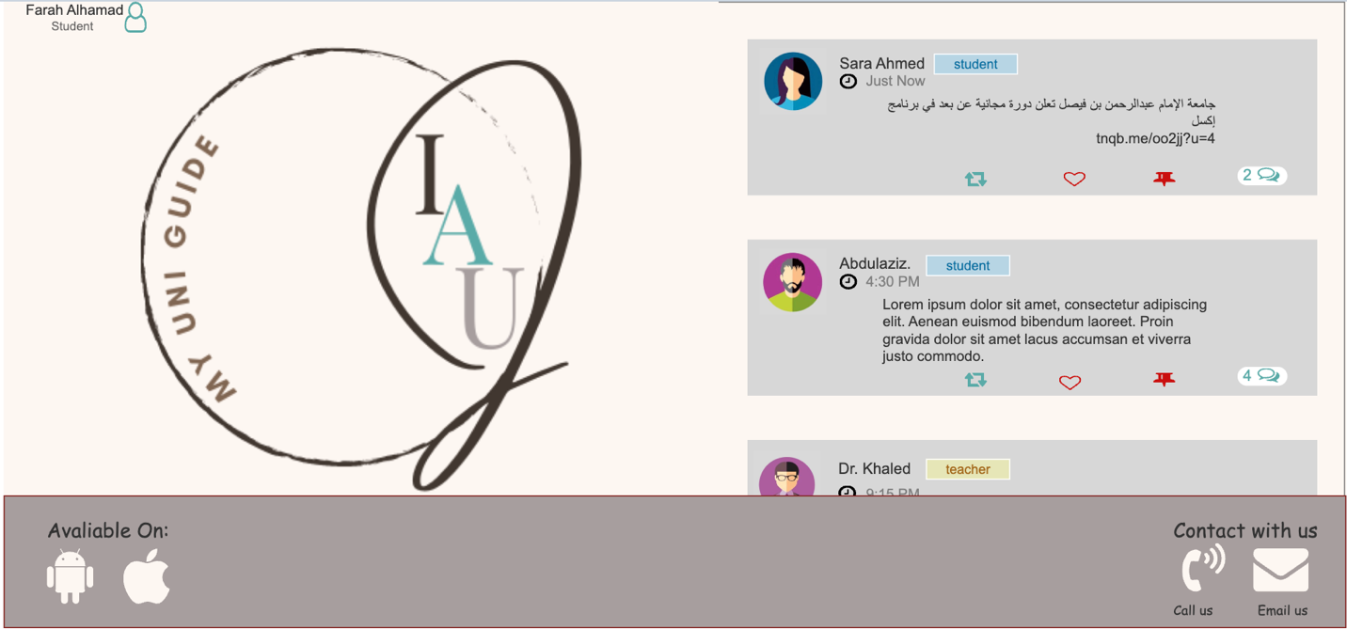

## Figure 36: Timeline page

The main page of our application where every student can view most events that they interested with or not and reach the rest page from.

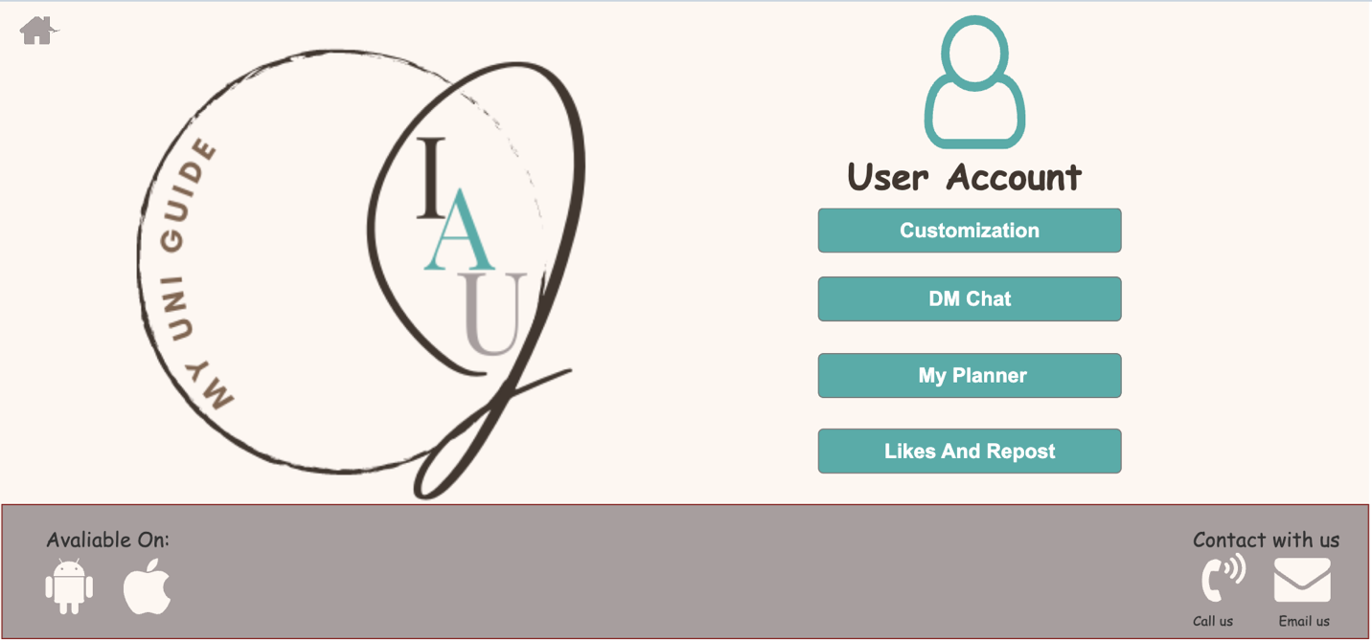

## Figure 37: User account page

In this page, the student's account appears, and the options for navigating the site appear, such as going to the page of likes and reposts, or the requests that he submitted, such as joining a published study group, or clicking on the settings to customize the page.

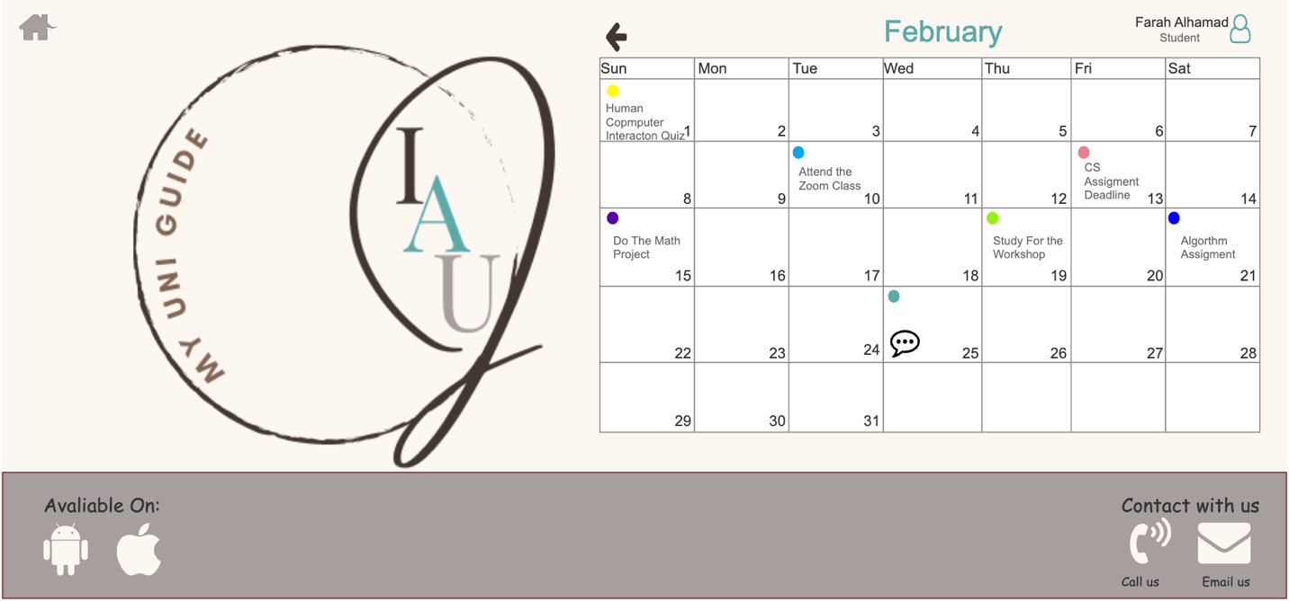

## Figure 38: My planner page

In this page each student can be able to schedule and make note of their own joined activities through a monthly calendar day by day, also the student can navigate between months.



## Figure 39: My planner page

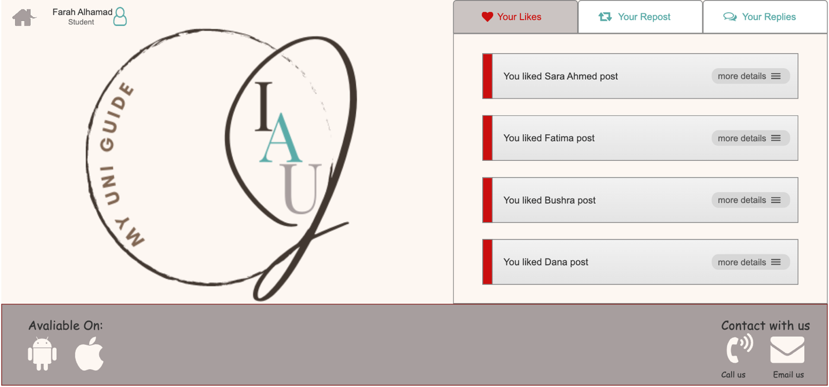

## Figure 40: Likes and Repost page

Shows on this page the publications that the User liked while browsing the Timeline page.

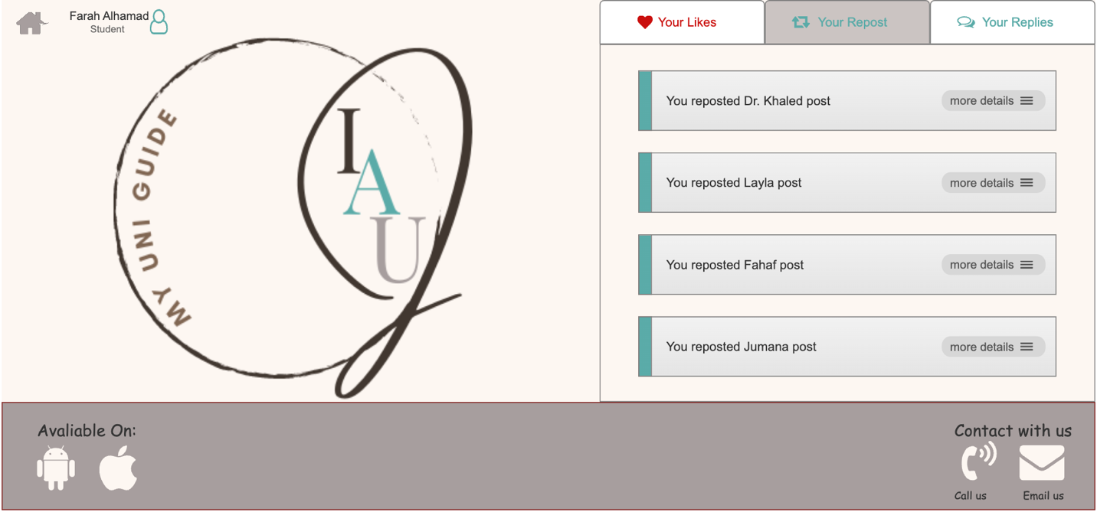

## Figure 41: Likes and Repost page

On this page the posts that the user has reposted while browsing the timeline in his account are displayed.

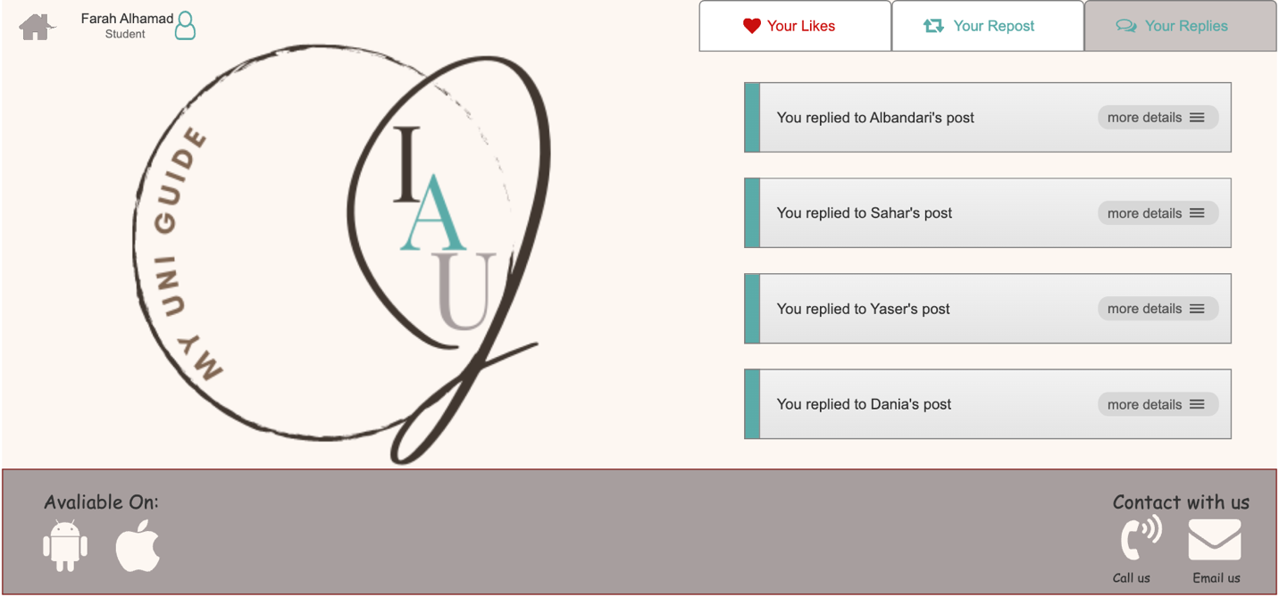

## Figure 42: Likes and Repost page

On this page the posts that the user has replies while browsing the timeline in his account are displayed.

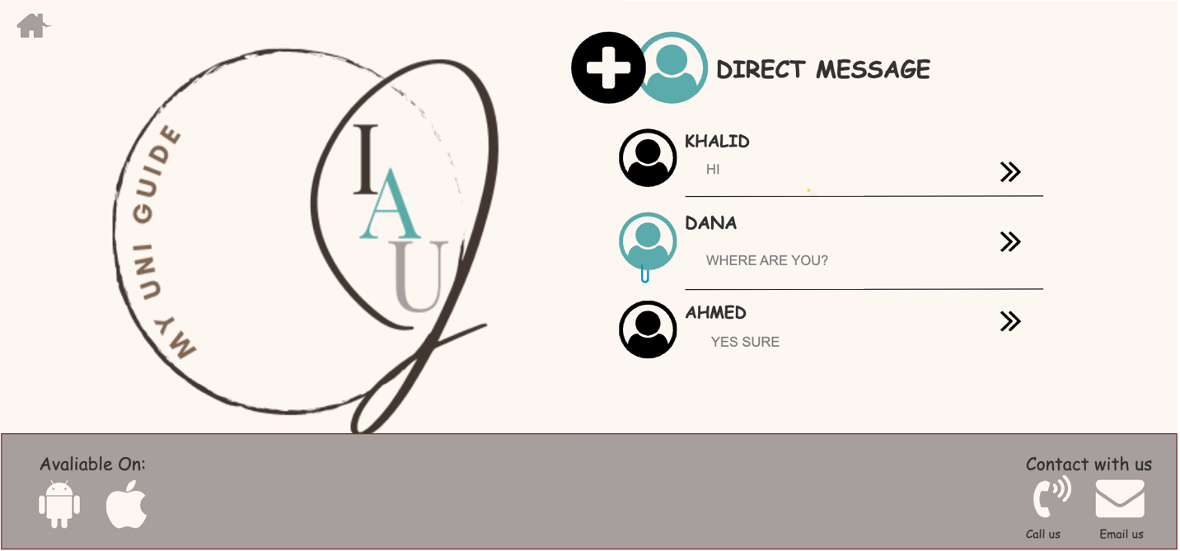

Figure 43: DM page 1

This page shows you the contact and the people you communicate with, it shows you the messages, also you can create a new chat with a new contact, then it will take you to the conversation of each person you have, and you can use the voice and video call feature.

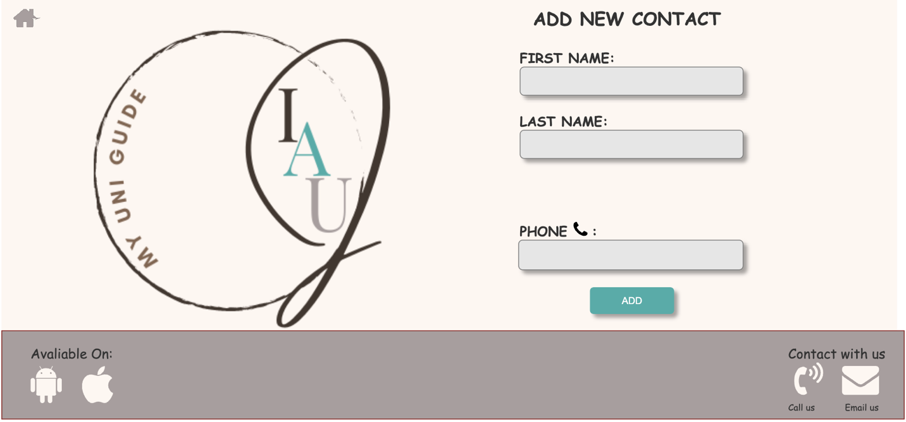

## Figure 44: Add new contact page

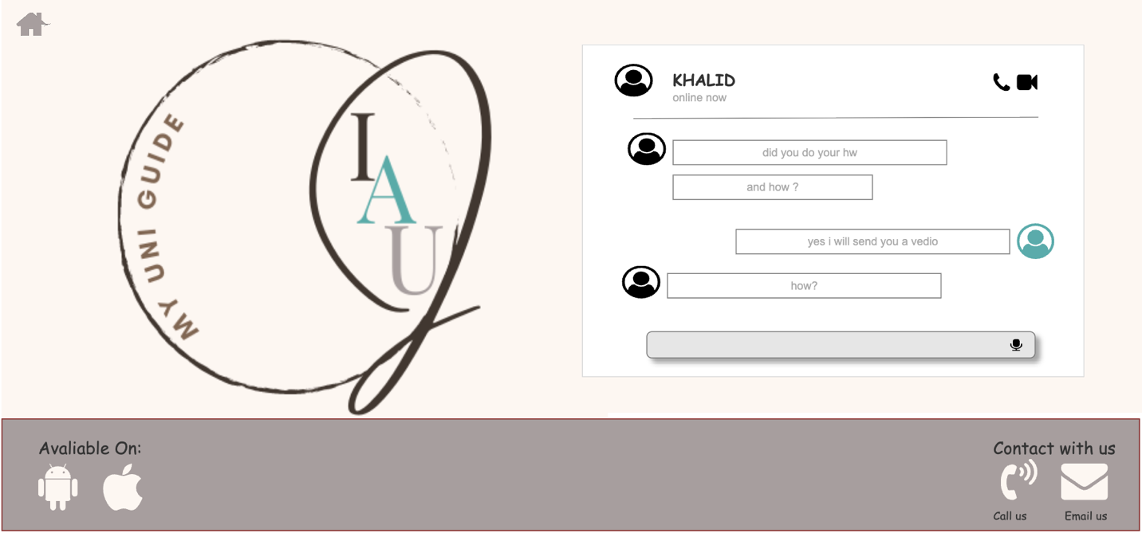

Figure 45: DM page 2

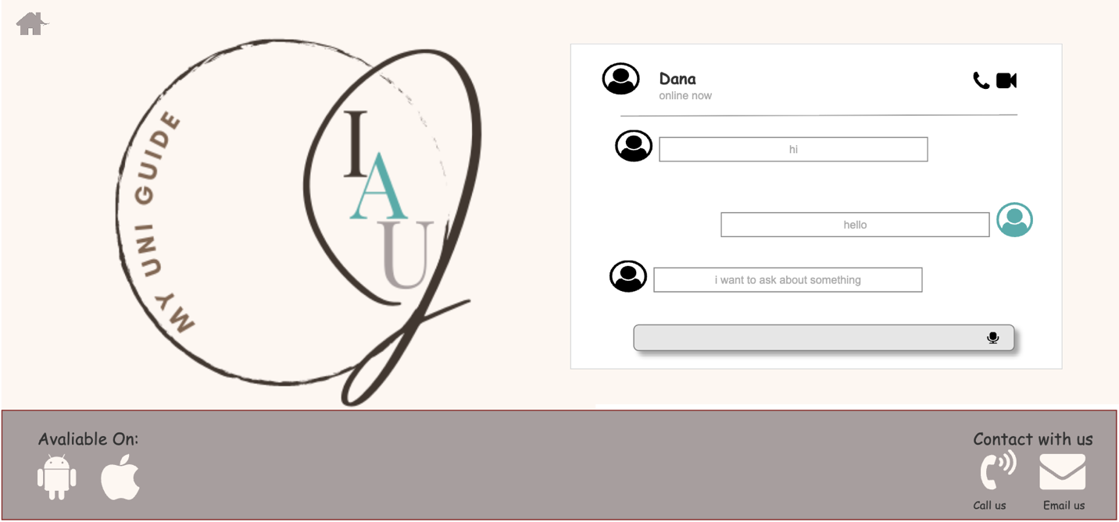

## Figure 46: DM page 3

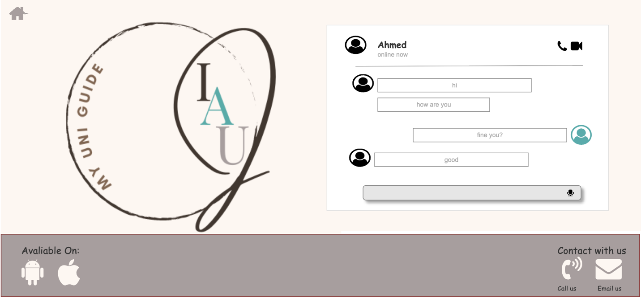

Figure 47: DM page 4



## Figure 48: Phone call page



## Figure 49: Video call page

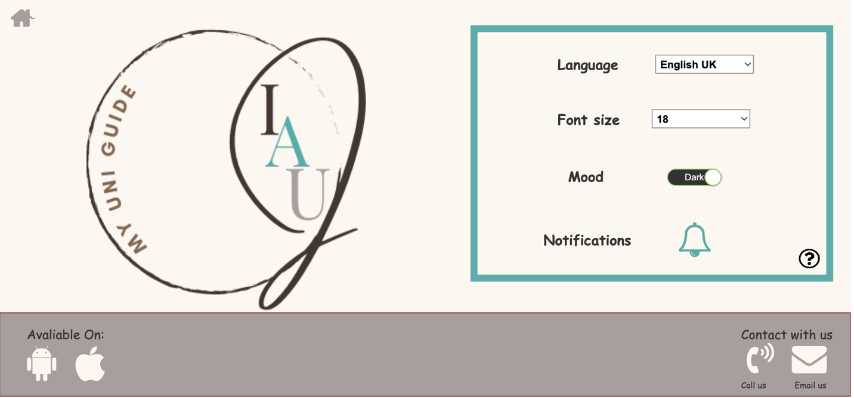

## Figure 50: Customization page

This page gives the user options to change the settings of the pages such as the mood (dark / light mood) and the language of the site. There is also a help field where the user can get help if he has any questions or problems by sending his problem to the team.



## Figure 51: Contact us page

This page enables the user to write his inquiry or comment that he would like to share, by entering the email and address, writing the comment, and sending it.

# **Concluding discussion:**

To sum up, we tried to consider that colleges sometimes don’t offer detailed instructions about some students needs, therefore at every beginning of a new year students face some difficulties in finding what they want. As a solution for that we did build a software to instruct and facilitates the process of searching for an information concerning college facilities, buildings locations, studying plans for all majors, reviews about courses and reference related to each course, also allows students to schedule meetings occasionally.

# **References:**

[1] Çetin, E. and Özdemir, S. (2013) *A study on an educational website's usability*, *Procedia - Social and Behavioral Sciences*. Elsevier. Available at: https://www.sciencedirect.com/science/article/pii/S1877042813011968 (Accessed: February 9, 2023).

[2] Beri, B. and Singh, P. (2013) “Web analytics: Increasing website's usability and conversion rate,” *International Journal of Computer Applications*, 72(6), pp. 35–38. Available at: https://doi.org/10.5120/12501-8420.

[3] Faranello, S. (2012) *Balsamiq wireframes quickstart guide*. Birmingham: Packt Publishing.

[4] Ishak, Z. *et al.* (2020) “Potential students preferences towards University website Interface Design:the methodology,” *2020 16th IEEE International Colloquium on Signal Processing & Its Applications (CSPA)* [Preprint]. Available at: https://doi.org/10.1109/cspa48992.2020.9068724.

[5] Lalji, Z. and Good, J. (2008) “Designing new technologies for illiterate populations: A study in mobile phone interface design,” *Interacting with Computers*, 20(6), pp. 574–586. Available at: https://doi.org/10.1016/j.intcom.2008.09.002.

[6] Krahenbuhl, J.H. (2015) *Learning axure RP interactive prototypes: A practical, step-by-step guide to creating engaging prototypes with Axure*. Birmingham, UK: Packt Publishing.